Re-Write SpringBoot

1. Introduction 2
Creating Spring Boot Application 3
2. Spring Boot Examples 5
1.Spring Boot with maven and Eclipse Example 5
2.Spring Boot with Spring Initializr Example 6
3. Spring Boot –Configurations 11
How to change Spring Boot Banner Text 11
application.properties 11
4. Spring Boot –MVC 12
Spring Boot MVC Example 13
Spring Boot –RESTful Web Service Example 16
5. Spring Boot –Database 17
Spring Boot –JDBC Example 17
Spring Boot –JPA Example 21
JpaRepository 27
Spring Boot –MongoDB REST Example 30
Spring Missing/ Confusing Topics 32
Diffrence between @Component & @Autowire 32
Diffrence beteen @ComponentScan & @Enable AutoCOnfiguration 32
AngularJS with SpringBoot 33
SpringBoot App UI 33
Basics 33
AngularJs internal working 35
Few More Examples 35
AngularJS Architecture Concepts 40
AngularJs + SpringBoot Example implementation 40
Integration Testing 41
MockMvc 41
Types of Authentication 41
HTTP Basic Authentication 42
Digest authentication 42
API Keys : for Developer Quickstart 43
OAuth Tokens: Great for Accessing User Data 43
LDAP 43
SSH – Only for LINUX Server / CommadLine(git) related Access 44
Base64 – not Authentication 45
Help.html 45
StudentApp Document 45

1. Introduction
Spring Boot makes it easy to create stand-alone, production-grade Spring based Applications that you can "just run".

Spring vs SpringBoot
Spring: Spring started as a lightweight alternative to Java Enterprise Edition (J2EE). Spring offered a simpler approach to enterprise Java development, utilizing dependency injection and aspect-oriented programming to achieve the capabilities of EJB with plain old Java objects (POJOs).
But while spring was lightweight in terms of component code, it was heavyweight in terms of configuration. Initially, spring was configured with XML & Spring 2.5 introduced annotation-based component-scanning, even so, there was no escape from configuration.
Spring boot: project is just a regular spring project that happens to leverage Spring Boot starters and auto-configuration. Spring Boot is not a framework, it is a way to ease to create stand-alone application with minimal or zero configurations.
Finally, Spring Boot is just spring. Spring projects would not have any XML configurations as part of it, everything will be handled by the project Spring Boot.
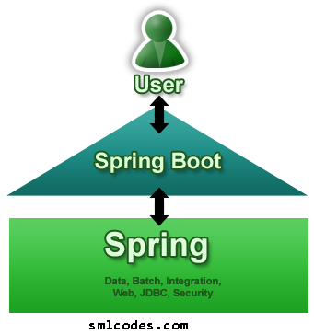
Spring Boot Features
- Create stand-alone Spring applications
- Embed Tomcat, Jetty or Undertow directly (no need to deploy WAR files)
- Provide opinionated 'starter' POMs to simplify your Maven configuration
- Automatically configure Spring whenever possible
- Provide production-ready features such as metrics, health checks and externalized configuration
- Absolutely no code generation and no requirement for XML configuration
We can develop two flavors of Spring-Based Applications using Spring Boot
- Java-Based Applications
- Groovy Application
Groovy is also JVM language almost similar to Java Language. We can combine both Groovy and Java into one Project. Because like Java files, Groovy files are finally compiled into *.class files only. Both *.groovy and *.java files are converted to *.class file (Same byte code format).
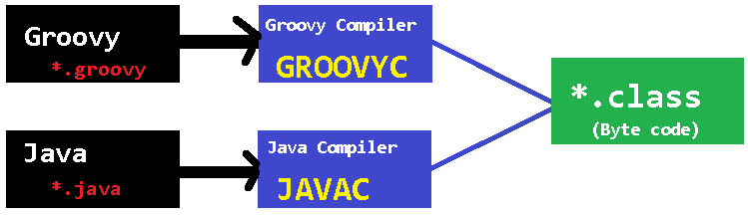
Spring Boot Framework Programming model is inspired by Groovy Programming model. Spring Boot internally uses some Groovy based techniques and tools to provide default imports and configuration.

Creating Spring Boot Application
To create Spring Boot based applications The Spring Team (The Pivotal Team) has provided the following three approaches.
- Using Maven
- Using Spring Initializer (http://start.spring.io/)
- Using Spring STS IDE
- Using Spring Boot CLI Tool

1. Spring Boot using Maven
Add maven dependencies in pom.xml & do maven build
<project>
<parent>
<groupId>org.springframework.boot</groupId>
<artifactId>spring-boot-starter-parent</artifactId>
<version>1.5.6.RELEASE</version>
</parent>

<dependencies>
<dependency>
<groupId>org.springframework.boot</groupId>
<artifactId>spring-boot-starter-web</artifactId>
</dependency>
</dependencies>

<properties>
<java.version>1.8</java.version>
</properties>

</project>

2.Spring Initializer
Spring Initializer provides an extensible API to generate quick start projects. It also provides a configurable service: you can see our default instance at https://start.spring.io. It provides a simple web UI to configure the project to generate and endpoints that you can use via plain HTTP.
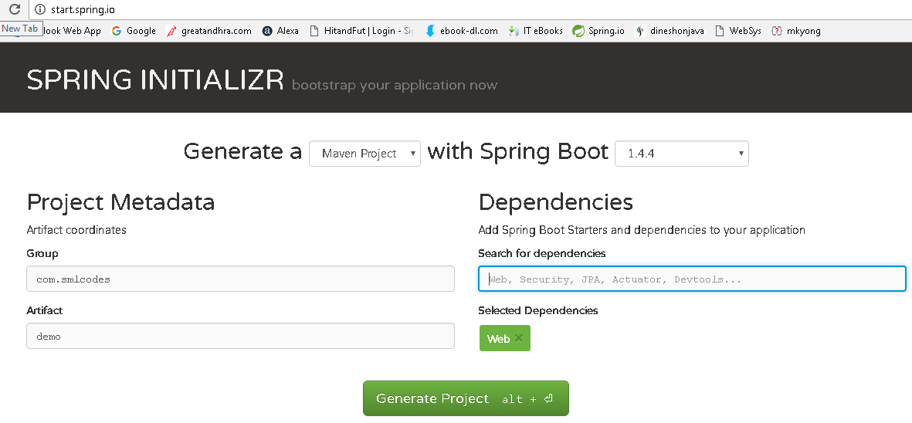
It will generate the Artifact.zip file, extract it and run maven build: mvn clean install package
[INFO] --- spring-boot-maven-plugin:1.4.4.RELEASE:repackage (default) @ SpringBootDemo ---
[INFO] ------------------------------------------------------------------------
[INFO] BUILD SUCCESS
[INFO] ------------------------------------------------------------------------
[INFO] Total time: 01:27 min
[INFO] Finished at: 2017-01-30T18:55:21+05:30
[INFO] Final Memory: 27M/160M
[INFO] ------------------------------------------------------------------------

3.Spring STS IDE
The Spring Tool Suite is an Eclipse-based development environment that is customized for developing spring applications. We can download it from here.
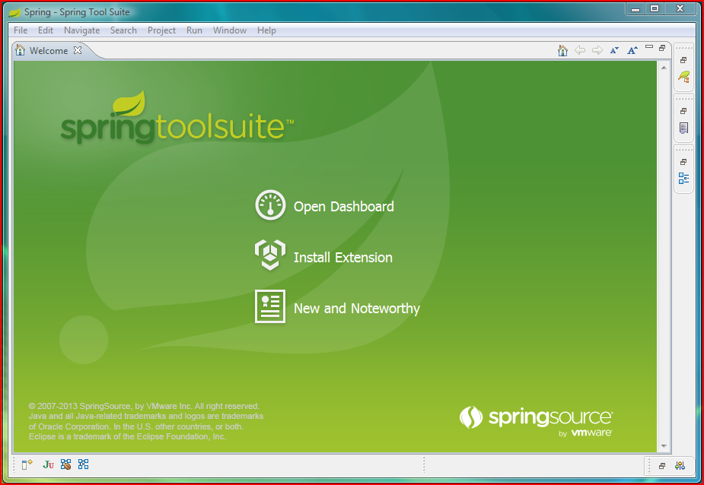

4.Spring Boot CLI Tool
The Spring Boot CLI is a command line tool that can be used if you want to quickly prototype (creates project Structure) with Spring. It allows you to run Groovy scripts, which means that you have a familiar Java-like syntax, without so much boilerplate code.
You don’t need to use the CLI to work with Spring Boot but it’s definitely the quickest way to get a spring application off the ground.
You can download the Spring CLI distribution from the Spring software repository:
- spring-boot-cli-1.5.0.RELEASE-bin.zip
- spring-boot-cli-1.5.0.RELEASE-bin.tar.gz
SDKMAN! (The Software Development Kit Manager) can be used for managing multiple versions of various binary SDKs, including Groovy and the Spring Boot CLI. Get SDKMAN! from sdkman.io and install Spring Boot with
$ sdk install springboot
$ spring --version
Spring Boot v1.5.0.RELEASE

A simple web application that you can use to test your installation. Create a file called app.groovy as
$ spring run app.groovy
It will take some time when you first run the application as dependencies are downloaded. Subsequent runs will be much quicker.

2. Spring Boot Examples

1.Spring Boot with maven and Eclipse Example
1. Open Eclipse > File > New > Maven Project
2.Tick ‘Create a simple project (skip archetype selection) ‘ check box > click Next
3. Provide Group Id (its your package), Artifact Id (project name) and click Finish
4. open pom.xml, add Spring Boot dependencies
<project>
<modelVersion>4.0.0</modelVersion>
<groupId>com.smlcodes</groupId>
<artifactId>SpringBootDemo</artifactId>
<version>0.0.1-SNAPSHOT</version>
<parent>
<groupId>org.springframework.boot</groupId>
<artifactId>spring-boot-starter-parent</artifactId>
<version>1.5.6.RELEASE</version>
</parent>

<dependencies>
<dependency>
<groupId>org.springframework.boot</groupId>
<artifactId>spring-boot-starter-web</artifactId>
</dependency>
</dependencies>

<properties>
<java.version>1.8</java.version>
</properties>
</project>
- spring-boot-starter-parent: is an existing project given by spring team which contains Spring Boot supporting configuration data (just configuration data, it won’t download any jars), we have added this in a <parent> tag means, we are instructing Maven to consider our SpringBootHelloWorld project as a child to it
- spring-boot-starter-web: Starter for building web, including RESTful, applications using Spring MVC. Uses Tomcat as the default embedded container

5.Now right click on the application > Maven > Update Project,
if you observe the directory structure of the project, it will create a new folder named “Maven Dependencies” which contains all supporting. jars to run the Spring Boot application and the Java version also changed to 1.8.
- if you observe pom.xml, we haven’t included version number for spring-boot-starter-web but maven downloaded some jar files with some version(s) related to spring-boot-starter-web, that’s because of Maven’s parent child relation.
- While adding spring boot parent project, we included version as 1.5.6.RELEASE, so again we no need to add version numbers for the dependencies. As we know spring-boot-starter-parent contains configuration meta data, this means, it knows which version of dependency need to be downloaded. So we no need to worry about dependencies versions., it will save lot of our time.

6.create a java class with main() method, in a pakage.com.smlcodes.app.SpringBootApp.java.
@SpringBootApplication
public class SpringBootApp {
public static void main(String[] args) {
SpringApplication.run(SpringBootApp.class, args);
System.out.println("****\n Hello, World \n ***");
}
}

- @SpringBootApplication annotation, is the starting point for our Spring Boot application
- SpringApplication.run(SpringBootApp.class, args); it will bootstrapping the application
remember, for every spring boot application we have to create a main class and that need to be annotate with @SpringBootApplication and bootstrap it

8.Finally, right click on the application > Run As > Java Application
. ____ _ __ _ _
/\\ / ___'_ __ _ _(_)_ __ __ _ \ \ \ \
( ( )\___ | '_ | '_| | '_ \/ _` | \ \ \ \
\\/ ___)| |_)| | | | | || (_| | ) ) ) )
' |____| .__|_| |_|_| |_\__, | / / / /
=========|_|==============|___/=/_/_/_/
:: Spring Boot :: (v1.5.6.RELEASE)

2017-09-11 16:04:04.006 INFO 6724 --- [ main] com.smlcodes.app.SpringBootApp : Starting SpringBootApp on HYDPCMCSTS with PID 6724
2017-09-11 16:04:13.444 INFO 6724 --- [ main] com.smlcodes.app.SpringBootApp : Started SpringBootApp in 10.738 seconds (JVM running for 12.252)
************
Hello, World
*****************

2.Spring Boot with Spring Initializr Example
we are using Spring Initializer(https://start.spring.io) to create a template for spring boot application
1. Go to https://start.spring.io , Choose Dependencies & Generate Project. Here we are not selecting any dependencies because it is just a Hello world program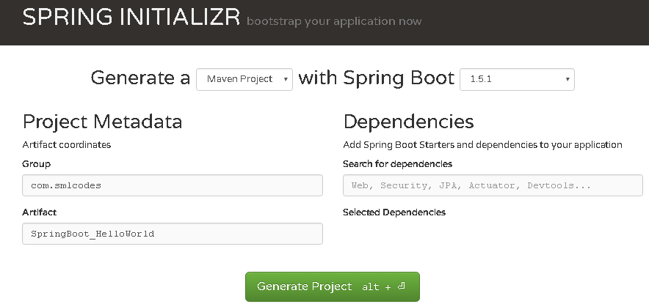

2. Open Eclipse, import→ Maven →Existing Maven Projects → Select Project →Finish

3. The Project structure will be as follows if we open eclipse Package explorer

4. If we open the pom.xml it contains only basic dependencies like spring-boot-starter which allows start spring boot application
<dependencies>
<dependency>
<groupId>org.springframework.boot</groupId>
<artifactId>spring-boot-starter</artifactId>
</dependency>
<dependency>
<groupId>org.springframework.boot</groupId>
<artifactId>spring-boot-starter-test</artifactId>
<scope>test</scope>
</dependency>
</dependencies>

5. Select Project, Right click Run as→ maven install to download and install the dependencies.

6.Spring boot generates the default java class which contains main() method. The main method calls the run method of SpringApplication. SpringApplication.run(SpringBootHelloWorldApplication.class, args); This run method bootstraps the application starting spring which will run the embedded Tomcat Server. Let’s add some helloworld message to print
package com.smlcodes;
import org.springframework.boot.SpringApplication;
import org.springframework.boot.autoconfigure.SpringBootApplication;

@SpringBootApplication
public class SpringBootHelloWorldApplication {
public static void main(String[] args) {
SpringApplication.run(SpringBootHelloWorldApplication.class, args);
System.out.println("============================================");
System.out.println("Hello World, Spring Boot!!!!");
System.out.println("=============www.smlcodes.com===============");
}
}
7. Select the Java file and right click RunAs → Java Application
/\\ / ___'_ __ _ _(_)_ __ __ _ \ \ \ \
( ( )\___ | '_ | '_| | '_ \/ _` | \ \ \ \
\\/ ___)| |_)| | | | | || (_| | ) ) ) )
' |____| .__|_| |_|_| |_\__, | / / / /
=========|_|==============|___/=/_/_/_/
:: Spring Boot :: (v1.5.1.RELEASE)
2017-01-31 11:05:32.745 INFO 29596 --- [ main] s.c.a.AnnotationConfigApplicationContext : Refreshing org.springframework.context.annotation.AnnotationConfigApplicationContext@646007f4: startup date [Tue Jan 31 11:05:32 IST 2017]; root of context hierarchy
2017-01-31 11:05:43.108 INFO 29596 --- [ main] o.s.j.e.a.AnnotationMBeanExporter : Registering beans for JMX exposure on startup
2017-01-31 11:05:43.200 INFO 29596 --- [ main] c.s.SpringBootHelloWorldApplication : Started SpringBootHelloWorldApplication in 12.855 seconds (JVM running for 16.094)
============================================
Hello World, Spring Boot!!!!
=============www.smlcodes.com===============

8. We can also run this application from the command line using the jar file that is generated. To get the jar file, select pom.xml right click RunAs → Maven Build (2nd one), goals=package, Apply & Run
[INFO] Building SpringBoot_HelloWorld 0.0.1-SNAPSHOT
[INFO] ----------------------------------------------------------------------
C:\Users\kaveti_s\Desktop\Downloads\SpringBoot_HelloWorld\SpringBoot_HelloWorld\target\SpringBoot_HelloWorld-0.0.1-SNAPSHOT.jar
[INFO] --- spring-boot-maven-plugin:1.5.1.RELEASE:repackage (default) @ SpringBoot_HelloWorld
[INFO] -------------------------------------------------------------------
[INFO] BUILD SUCCESS
[INFO] -------------------------------------------------------------------

9. Open command line and go to the folder where your project is located. Next, move to the target folder and then type java -jar <<filename>>.jar.
java -jar SpringBoot_HelloWorld-0.0.1-SNAPSHOT.jar

How it works internally
1. we place the all the required Spring boot starters in pom.xml which are requires for implementing Spring Boot application. on loading project, the all required starter dependencies are added automatically to the project
2. By running Spring Boot main class, at @SpringBootApplication line it will do the Auto configuration things, it will automatically add all required annotations to Java Class ByteCode.
3.On Executing main() method SpringApplication.run() used to bootstrap and launches Spring Boot application.

1.Spring Boot Starters
Spring boot Starters are the one-stop-shop for all the Spring and related technology that we need. For example, if you want to get started using Spring and JPA for database access, just include the spring-boot-starter-data-jpa dependency in your project, and you are good to go.
All official starters follow a similar naming pattern; spring-boot-starter-*, where * is a particular type of application. The following are the some of the application starters are provided by Spring Boot under the org.springframework.boot group
Name | Description
spring-boot-starter-web-services | Starter for using Spring Web Services
spring-boot-starter-web | Starter for building web, including RESTful, applications using Spring MVC. Uses Tomcat as the default embedded container
spring-boot-starter-test | Starter for testing Spring Boot applications with libraries including JUnit, Hamcrest and Mockito
spring-boot-starter-jdbc | Starter for using JDBC with the Tomcat JDBC connection pool
spring-boot-starter-jersey | Starter for building RESTful web applications using JAX-RS and Jersey. An alternative to spring-boot-starter-web
spring-boot-starter-aop | Aspect-oriented programming with Spring AOP and AspectJ
spring-boot-starter-security | Starter for using Spring Security
spring-boot-starter-data-jpa | Starter for using Spring Data JPA with Hibernate
spring-boot-starter | Core starter, including auto-configuration support, logging,YML

In above Example we used spring-boot-starter & spring-boot-starter-test Starters which are configure in pom.xml
<dependencies>
<dependency>
<groupId>org.springframework.boot</groupId>
<artifactId>spring-boot-starter</artifactId>
</dependency>
<dependency>
<groupId>org.springframework.boot</groupId>
<artifactId>spring-boot-starter-test</artifactId>
<scope>test</scope>
</dependency>
</dependencies>

2.@SpringBootApplication Annotation
This annotation marks the class as a spring bean, configures the application by adding all the jars based on the dependencies and also scans the other packages for spring beans.
Spring Boot developers always have their main class annotated with @Configuration, @EnableAutoConfiguration and @ComponentScan.
- @Configuration – Specifies this class as a spring bean
- @EnableAutoConfiguration –
  - This tells how you want to configure Spring, based on the jar dependencies that you have added. & also Enable / Disable auto configuration.
  - Spring Boot auto-configuration attempts to automatically configure your Spring application based on the jar dependencies that you have added.
  - For example, if HSQLDB is on your classpath, and you have not manually configured any database connection beans, then Spring Boot auto-configures an in-memory database
  - We can disble AutoConfiguration specific files by @EnableAutoConfiguration(exclude={DataSourceAutoConfiguration.class})

- @ComponentScan – is to scan other packages for spring beans.
- @Import - used to import additional configuration classes
- @ImportResource -annotation to load XML configuration files
import org.springframework.boot.SpringApplication;
import org.springframework.boot.autoconfigure.EnableAutoConfiguration;
import org.springframework.context.annotation.ComponentScan;
import org.springframework.context.annotation.Configuration;

@Configuration
@EnableAutoConfiguration
@ComponentScan
public class Application {
public static void main(String[] args) {
SpringApplication.run(Application.class, args);
}
}
Since these annotations are so frequently used together Spring Boot provides a convenient @SpringBootApplication as an alternative. The @SpringBootApplication annotation is equivalent to using @Configuration, @EnableAutoConfiguration and @ComponentScan with their default attributes.
@SpringBootApplication = @Configuration + @ComponentScan + @EnableAutoConfiration.
The original @SpringBootApplication annotation class is defined as below
package org.springframework.boot.autoconfigure; @Target(ElementType.TYPE)
@Retention(RetentionPolicy.RUNTIME)
@Documented
@Inherited
@Configuration
@EnableAutoConfiguration
@ComponentScan
public @interface SpringBootApplication {
Class<?>[] exclude() default {};

String[] excludeName()default{};

@AliasFor(annotation = ComponentScan.class, attribute = "basePackages")
String[] scanBasePackages() default {};

@AliasFor(annotation = ComponentScan.class, attribute = "basePackageClasses")
Class<?>[] scanBasePackageClasses()default{};
}

3 SpringApplication Class
SpringApplication class is used to bootstrap and launch a Spring application from a Java main method. By default, class will perform the following steps to bootstrap your application:
- Create an appropriate ApplicationContext instance (depending on your classpath)
- Register a CommandLinePropertySource to expose command line arguments as Spring properties
- Refresh the application context, loading all singleton beans
- Trigger any CommandLineRunner beans
In most circumstances the static run(Object, String[]) method can be called directly from your main method to bootstrap your application:
public static void main(String[] args) {
SpringApplication.run(MySpringConfiguration.class, args);
}

4. Embaded Servlet containers
The following embedded servlet containers are supported out of the box.By default we will get Tomcat
Name | Servlet Version | Java Version
Tomcat 8 | 3.1 | Java 7+
Tomcat 7 | 3.0 | Java 6+
Jetty 9.3 | 3.1 | Java 8+
Jetty 9.2 | 3.1 | Java 7+
Jetty 8 | 3.0 | Java 6+
Undertow 1.3 | 3.1 | Java 7+

5.Spring Boot Profiles (@Profile Annotation)
Spring Profiles provide a way to segregate parts of your application configuration and make it only available in certain environments. Any @Component or @Configuration can be marked with @Profile to limit when it is loaded
@Configuration
@Profile("production")
public class ProductionConfiguration {

// ...

}
In the normal Spring way, you can use a spring.profiles.active Environment property to specify which profiles are active. You can specify the property in any of the usual ways, for example you could include it in your application.properties:spring.profiles.active=dev,hsqldb or specify on the command line using the switch --spring.profiles.active=dev,hsqldb.

6. Spring Boot Actuator
Spring Boot provides actuator to monitor and manage our application. Actuator is a tool which has HTTP endpoints. when application is pushed to production, you can choose to manage and monitor your application using HTTP endpoints.
To get production-ready features, we should use spring-boot-actuator module. We can enable this feature by adding it to the pom.xml file.
<dependencies>
<dependency>
<groupId>org.springframework.boot</groupId>
<artifactId>spring-boot-starter-actuator</artifactId>
</dependency>
</dependencies>

3. Spring Boot –Configurations

How to change Spring Boot Banner Text
The banner that is printed on startup can be changed by adding a banner.txt file to src\main\resources folder or your classpath, or by setting banner.location to the location of such a file.
You can also add a banner.gif, banner.jpg or banner.png image file to your classpath, or set a banner.image.location property. Images will be converted into an ASCII art representation and printed above any text banner.
- Go to any ANCII Text generator website & generate your logo. for ex: http://patorjk.com/
- Create banner.txt under Proj_Home\src\main\resources, paste the logo text
- Refresh the project & run Spring Boot Application.the banner will change as below
██████╗███╗ ███╗██╗ ██████╗ ██████╗ ██████╗ ███████╗███████╗
██╔════╝████╗ ████║██║ ██╔════╝██╔═══██╗██╔══██╗██╔════╝██╔════╝
███████╗██╔████╔██║██║ ██║ ██║ ██║██║ ██║█████╗ ███████╗
╚════██║██║╚██╔╝██║██║ ██║ ██║ ██║██║ ██║██╔══╝ ╚════██║
███████║██║ ╚═╝ ██║███████╗╚██████╗╚██████╔╝██████╔╝███████╗███████║
╚══════╝╚═╝ ╚═╝╚══════╝ ╚═════╝ ╚═════╝ ╚═════╝ ╚══════╝╚══════╝
2017-02-01 14:07:22.957 INFO 72716 --- [ main] c.s.SpringBootHelloWorldApplication

application.properties
Spring Boot provides a very neat way to load properties for an application. we can define properties in application.properties (PROJ_HOME\src\main\resources\application.properties) file the following way
db.name=smlcodesdb
db.username=smlcodes
db.password=wEB20R1XPJtg9

In traditional Spring application would have loaded up the properties in the following way
public class SmlcodesPropTest {
@Value("${db.name}") //dbname is KEY here
private String dbname;

@Value("${db. username }")
private String server_port;
In Spring boot it takes application. properties file to define a bean that can hold all the related properties in following way
@ConfigurationProperties(prefix = "db")
@Component
public class DBConfig {

public String dbname;
public String username;
public String password;

public String getDbname() {
return dbname;
}
public void setDbname(String dbname) {
this.dbname = dbname;
}
public String getUsername() {
return username;
}
public void setUsername(String username) {
this.username = username;
}
public String getPassword() {
return password;
}
public void setPassword(String password) {
this.password = password;
}

}

@ConfigurationProperties is used to bind and validate some external Properties. If we want to validate before going to use, we have to place @Validated & place type of validation on the filed
@ConfigurationProperties(prefix="foo")
@Validated
public class FooProperties {

@NotNull
private InetAddress remoteAddress;
// ... getters and setters
}

4. Spring Boot –MVC
In old Spring MVC lets you create special @Controller or @RestController beans to handle incoming HTTP requests. Methods in your controller are mapped to HTTP using @RequestMapping annotations.
SpringMVC example @RestController to serve JSON data
@RestController
@RequestMapping(value="/users")
public class SmlCodesRestController {

@RequestMapping(value="/{user}", method=RequestMethod.GET)
public User getUser(@PathVariable Long user) {
// ...
}

@RequestMapping(value="/{user}/customers", method=RequestMethod.GET)
List<Customer> getUserCustomers(@PathVariable Long user) {
// ...
}

@RequestMapping(value="/{user}", method=RequestMethod.DELETE)
public User deleteUser(@PathVariable Long user) {
// ...
}

}

Spring Boot MVC Example
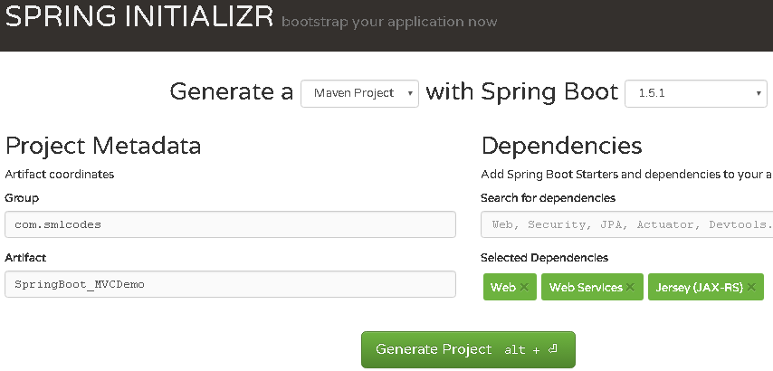
Extract, import to eclipse as Existing Maven project, & Run as→ maven install
If we see the Folder Structre
- all index, welcome files must be placed unter →resources\static\
- all the result pages must be placed under→resources\templates\
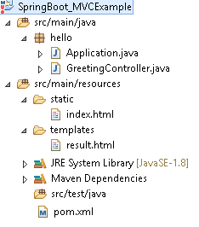

1.Choose the SpringBoot Stater Dependencies and place in pom.xml & build the project.
<?xml version="1.0" encoding="UTF-8"?>
<project xmlns="http://maven.apache.org/POM/4.0.0" xmlns:xsi="http://www.w3.org/2001/XMLSchema-instance"
xsi:schemaLocation="http://maven.apache.org/POM/4.0.0 http://maven.apache.org/xsd/maven-4.0.0.xsd">
<modelVersion>4.0.0</modelVersion>

<groupId>SpringBoot_MVCExample</groupId>
<artifactId>gs-serving-web-content</artifactId>
<version>SpringBoot_MVCExample</version>

<parent>
<groupId>org.springframework.boot</groupId>
<artifactId>spring-boot-starter-parent</artifactId>
<version>1.5.1.RELEASE</version>
</parent>

<dependencies>
<dependency>
<groupId>org.springframework.boot</groupId>
<artifactId>spring-boot-starter-test</artifactId>
<scope>test</scope>
</dependency>
</dependencies>

<properties>
<java.version>1.8</java.version>
</properties>

<build>
<plugins>
<plugin>
<groupId>org.springframework.boot</groupId>
<artifactId>spring-boot-maven-plugin</artifactId>
</plugin>
</plugins>
</build>

</project>

2.Create index.html to provide user input
///SpringBoot_MVCExample/src/main/resources/static/index.html
<h2>Spring Boot MVC Example</h2>
<form method="get" action="/hello">
<h3>Enter Your name : <input type="text" name="name"></h3>
<button type="submit">Enter</button>
</form>

3.Create Controller to hadle request given by user (/hello)
package hello;
import org.springframework.stereotype.Controller;
import org.springframework.ui.Model;
import org.springframework.web.bind.annotation.RequestMapping;
import org.springframework.web.bind.annotation.RequestParam;

@Controller
public class GreetingController {

@RequestMapping("/hello")
public String greeting(@RequestParam(value="name", required=false, defaultValue="World") String name, Model model) {
model.addAttribute("name", name);
return "result";
}
}
Here Model is a interface which conatins some usefull method to return result data to result page

4.Create result.html template to display the Results given by Controller
<!DOCTYPE HTML>
<html xmlns:th="http://www.thymeleaf.org">
<body>
<h1><p th:text="'Hello, ' + ${name} + '!'" /></h1>
</body>
</html>

5.Create Application.java to Start & Run Spring Boot Application
package hello;
import org.springframework.boot.SpringApplication;
import org.springframework.boot.autoconfigure.SpringBootApplication;

@SpringBootApplication
public class Application {
public static void main(String[] args) {
SpringApplication.run(Application.class, args);
}
}

6.Strat the Application by Run as→ Java Application (Application.java)
. ____ _ __ _ _
/\\ / ___'_ __ _ _(_)_ __ __ _ \ \ \ \
( ( )\___ | '_ | '_| | '_ \/ _` | \ \ \ \
\\/ ___)| |_)| | | | | || (_| | ) ) ) )
' |____| .__|_| |_|_| |_\__, | / / / /
=========|_|==============|___/=/_/_/_/
:: Spring Boot :: (v1.5.1.RELEASE)
2017-02-02TomcatEmbeddedServletContainer : Tomcat started on port(s): 8080
7.Open browser, access localhost:8080 the Output should be as below
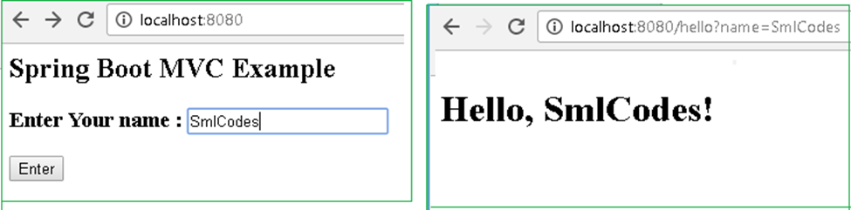

Explanation
1.On Running Applicatio.java, Spring Boot Engine Starts and reads the all files in the projects and autowires the data and auto configures the Controller details
2.on submitting the form, Spring Boot Searchers for controller classes which are annotated with @Controller
3.compairs (“/hello”) path with controller @RequestMapping("/hello"), if matches execute the business logic method and it returns the resultpage name(“result”)
4.SpringBoot Engine Searches the appropriate resultpage template having “result” as page name & displays the result.html page to the user

1.Model Interface
Model interface designed for adding attributes to the model. Allows for accessing the overall model as a java.util.Map.
Method Summary
Model | addAllAttributes(Collection<?> attributeValues)  Copy all attributes in the supplied Collection into this Map,
Model | addAllAttributes(Map<String,?> attributes)  Copy all attributes in the supplied Map into this Map.
Model | addAttribute(Object attributeValue)  Add the supplied attribute to this Map using a generated name.
Model | addAttribute(String attributeName, Object attributeValue)  Add the supplied attribute under the supplied name.
Map<String,Object> | asMap() - Return the current set of model attributes as a Map.
boolean | containsAttribute(String attributeName)  Does this model contain an attribute of the given name?
Model | mergeAttributes(Map<String,?> attributes)

2.Static Content
By default, Spring Boot will serve static content from a directory called /static (or /public or /resources or /META-INF/resources)
You can also customize the static resource locations using spring.resources.static-locations (replacing the default values with a list of directory locations).
If you do this the default welcome page detection will switch to your custom locations, so if there is an index.html in any of your locations on startup, it will be the home page of the application.

Spring Boot –RESTful Web Service Example
To work with webservices in SpringBoot we have to use two annotations
- @RestController: tells Spring Boot to consider this class as REST controller
- @RequestMapping: used to register paths inside it to respond to the HTTP requests.
The @RestController is a stereotype annotation. It adds @Controller and @ResponseBody annotations to the class.
@RestController = @Controller + @ResponseBody
Note - The @RestController and @RequestMapping annotations are Spring MVC annotations. They are not specific to Spring Boot.
app.controller.SpringBootRestController.java
package app.controller;
@RestController
public class SpringBootRestController {

@RequestMapping("/")
public String welcome() {
return "Spring Boot Home Page";
}

@RequestMapping("/hello")
public String myData() {
return "Smalcodes : Hello Spring Boot";
}
}

app.SpringBootApp.java
@SpringBootApplication
public class SpringBootApp {
public static void main(String[] args) {
SpringApplication.run(SpringBootApp.class, args);
}
}

Create pom.xml same as fisrt example.
Test the Application
Right click on project > Run as >Java Application >select SpringBootApp
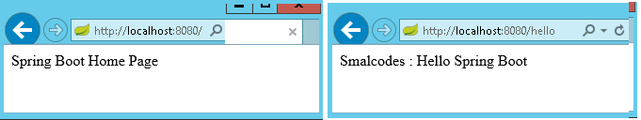
- In above Spring Boot main application class in app package and controller class in app.controller. While starting our application, SpringBootApp class will scan all the components under that package. As we have created our controller class in app.controller which is inside app package, our controller was registered by spring boot.

- If you create the controller class outside of the main package, lets say com.smlcodes.controller, If you run the application it gives 404 error.To resolve this, we have to add @ComponentScan annotation in our Spring Boot main class, as below
@SpringBootApplication
@ComponentScan(basePackages="smlcodes.controller")
public class SpringBootApp {
public static void main(String[] args) {
SpringApplication.run(SpringBootApp.class, args);
}
}

5. Spring Boot –Database

Spring Boot –JDBC Example
Spring Boot provides starter and libraries for connecting to our application with JDBC. Spring JDBC dependencies can be resolved by using either spring-boot-starter-jdbc or spring-boot-starter-data-jpa spring boot starters.

1.Create project Structure
To create project go to https://start.spring.io/ and add JDBC,MySQL,JPA dependencies to the Project.

Configure DataSource (application. properties)
DataSource and Connection Pool are configured in application.properties file using prefix spring.datasource. Spring boot uses javax.sql.DataSource interface to configure DataSource
spring.datasource.url=jdbc:mysql://localhost:3306/springdb?useSSL=false
spring.datasource.username=root
spring.datasource.password=root
spring.datasource.driver-class-name=com.mysql.jdbc.Driver

Model Class(model.Student.java)
Find the MySQL table used in our example.
CREATE TABLE `student` (
`sno` INT(11) NOT NULL,
`name` VARCHAR(50) NULL DEFAULT NULL,
`address` VARCHAR(50) NULL DEFAULT NULL,
PRIMARY KEY (`sno`)
)
COLLATE='latin1_swedish_ci'
ENGINE=InnoDB
;

Create Student class with table properties
package app.model;

public class Student {
private int sno;
private String name;
private String address;

public Student() {
super();
}

public Student(int sno, String name, String address) {
super();
this.sno = sno;
this.name = name;
this.address = address;
}

public int getSno() {
return sno;
}

public void setSno(int sno) {
this.sno = sno;
}

public String getName() {
return name;
}

public void setName(String name) {
this.name = name;
}

public String getAddress() {
return address;
}

public void setAddress(String address) {
this.address = address;
}

}

DAO Class with JdbcTemplate (StudentDAO.java)
- JdbcTemplate is the central class to handle JDBC. It executes SQL queries and fetches their results. To use JdbcTemplate.
- JdbcTemplate dependency injection using @Autowired with constructor.
package app.dao;

import org.springframework.beans.factory.annotation.Autowired;
import org.springframework.jdbc.core.JdbcTemplate;
import org.springframework.stereotype.Repository;
import app.model.Student;

@Repository
public class StudentDAO {

@Autowired
private JdbcTemplate template;

public List<Student> findAll() {

List<Student> result = template.query("SELECT sno,name, address FROM Student", new StudentRowMapper());
return result;
}

public void addStudent(int sno, String name, String address) {
template.update("INSERT INTO Student(sno,name, address) VALUES (?,?,?)", sno, name, address);
}

}

RowMapper Class
Spring JDBC provides RowMapper interface that is used to map row with a java object. We need to create our own class implementing RowMapper interface to map row with java object. Find the sample code to implement RowMapperinterface.
It is a Functional interface we have only one method mapRow(ResultSet rs, int rowno)
package app.dao;

import org.springframework.jdbc.core.RowMapper;
import app.model.Student;

public class StudentRowMapper implements RowMapper<Student> {
@Override
public Student mapRow(ResultSet rs, int rowno) throws SQLException {
// TODO Auto-generated method stub
Student s = new Student();
s.setSno(rs.getInt("sno"));
s.setName(rs.getString("name"));
s.setAddress(rs.getString("address"));
return s;
}
}

SpringBootJdbcController.java
package app.controller;
import org.springframework.web.bind.annotation.RestController;
import app.dao.StudentDAO;
import app.model.Student;
import java.util.Iterator;
import java.util.List;
import org.springframework.beans.factory.annotation.Autowired;
import org.springframework.web.bind.annotation.RequestMapping;
import org.springframework.web.bind.annotation.RequestParam;

@RestController
public class SpringBootJDBCController {

@Autowired
private StudentDAO dao;

@RequestMapping("/jdbc")
public String welcome() {
return "Spring Boot Home Page";
}

@RequestMapping("/insert")
public String insert(@RequestParam("sno") int sno, @RequestParam("name") String name,
@RequestParam("address") String adr) {
System.out.println(" ************** Inside Method ************");

dao.addStudent(sno, name, adr);
return "Data Inserted";
}

@RequestMapping("/select")
public String select() {
String result="";
List<Student> list = dao.findAll();
Iterator<Student> itr = list.iterator();
while (itr.hasNext()) {
Student s = (Student) itr.next();
result = result+ s.getSno()+", ";
result = result+ s.getName()+", ";
result = result+ s.getAddress()+" <br>";
}
System.out.println("Result : "+result);
return result;
}
}

SpringBootApp.java
package app;
import org.springframework.boot.SpringApplication;
import org.springframework.boot.autoconfigure.SpringBootApplication;

@SpringBootApplication
public class SpringBootApp {
public static void main(String[] args) {
SpringApplication.run(SpringBootApp.class, args);
}
}
Static/index.jsp
<a href="/select">SELECT</a><br />

<h1>Insert Form</h1>
<form action="/insert">
Sno: <input name="sno" type="text" /> <br>
Name: <input name="name" type="text" /> <br>
Address: <input name="address" type="text" /> <br>
<input type="submit" value="INSERT" /> <br>
</form>
</body>
</html>

Rightclikc on Project> Runas> Java Application 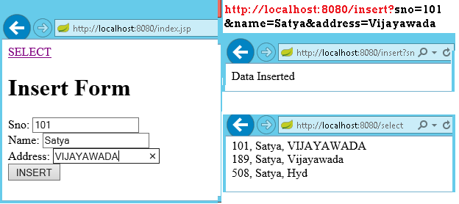

We can discard RowMapper class if we write following code in StudentDAO class it self.
@Repository
public class StudentDAO {

@Autowired
private JdbcTemplate template;

public List<Student> findAll() {

List<Student> result = template.query("SELECT sno,name, address FROM Student",
(rs, rowNum) -> new Student(rs.getInt("sno"),
rs.getString("name"), rs.getString("address")));
return result;

}

public void addStudent(int sno, String name, String address) {
template.update("INSERT INTO Student(sno,name, address) VALUES (?,?,?)",
sno, name, address);
}
}

Spring Boot –JPA Example
Spring Boot provides spring-boot-starter-data-jpa starter to connect Spring application with relational database efficiently. You can use it into project POM (Project Object Model) file.

JPA Annotations
By default, each field is mapped to a column with the name of the field. You can change the default name via @Column (name="newColumnName").
The following annotations can be used.
@Entity | Marks java class to a Table name
@Table(name="tabname") | Provides table name, when table name & class names are different .
@Id | Identifies the unique ID of the database entry
@GeneratedValue | Together with an ID this annotation defines that value is generated automatically.
@Transient | Field will not be saved in database
The central interface in Spring Data repository abstraction is Repository (probably not that much of a surprise). It takes the domain class to manage as well as the id type of the domain class as type arguments.

Spring 4 Data
Spring Data Commons provides all the common abstractions that enable you to connect with different data stores.
Spring Data Coomons provides classes & methods, which are common for all the SQL, NoSQL, BigData databases
The Spring Data Commons project provides general infrastructure and interfaces for the other, more specific data projects. Regardless of the type of datastore, Spring Data supports the following aspects with a single API:
- Execute CRUD (create, read, update, delete) operations
- Sorting
- Page-wise reading (pagination)
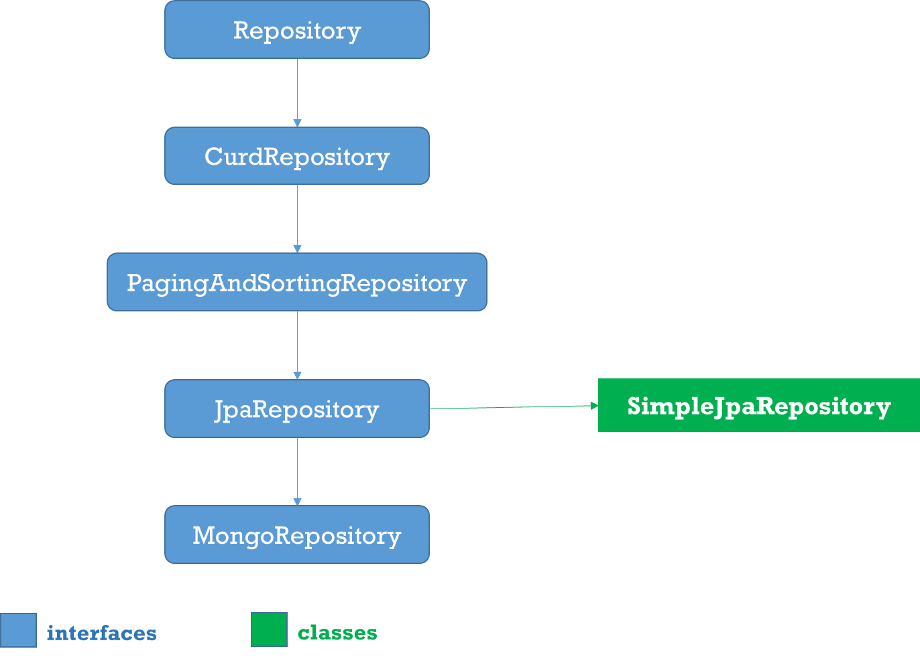

1.Repositoy
Root interface for all Repositoty classes. It is a marker interface(no methods)

2.CurdRepositoy
It provides generic CRUD operations irrespective of the underlying database. It extends Repository interface.
public interface CrudRepository<T, ID> extends Repository<T, ID> {
save(S entity);
saveAll(Iterable<S> entities);

Optional<T> findById(ID id);
Iterable<T> findAll();
Iterable<T> findAllById(Iterable<ID> ids);

void deleteById(ID id);
void delete(T entity);
void deleteAll(Iterable<? extends T> entities);
void deleteAll();

boolean existsById(ID id);
long count();
}

3.PagingAndSortingRepository
PagingAndSortingRepository provides options to
- Sort your data using Sort interface
- Paginate your data using Pageable interface, which provides methods for pagination - getPageNumber(), getPageSize(), next(), previousOrFirst() etc
public abstract interface PagingAndSortingRepository extends CrudRepository {

public Iterable findAll(Sort sort);
public Page findAll(Pageable pageable);

}

4.JpaRepository
JPA specific extension of Repository
public interface JpaRepository<T, ID extends Serializable> extends
PagingAndSortingRepository<T, ID> {
List<T> findAll();
List<T> findAll(Sort sort);
List<T> save(Iterable<? extends T> entities);
void flush();
T saveAndFlush(T entity);
void deleteInBatch(Iterable<T> entities);
}

5.MongoRepository
Mongo specific Repository interface.
public interface MongoRepository<T, ID> extends PagingAndSortingRepository {
List<T> findAll()
List<T> findAll(Sort sort)

List<S> saveAll(Iterable<S> entities)
List<S> insert(Iterable<S> entities)
S insert(S entity)

}

6.Custom Repository
- You can create a custom repository extending any of the repository classes - Repository, PagingAndSortingRepository or CrudRepository. For example,
interface PersonRepository extends CrudRepository<User, Long> {
}
- Spring Data also provides the feature of query creation from interface method names.
interface PersonRepository extends Repository<User, Long> {

List<Person> findByEmailAddressAndLastname(EmailAddress emailAddress, String lastname);

// Enables the distinct flag for the query
List<Person> findDistinctPeopleByLastnameOrFirstname(String lastname, String firstname);
List<Person> findPeopleDistinctByLastnameOrFirstname(String lastname, String firstname);

// Enabling ignoring case for an individual property
List<Person> findByLastnameIgnoreCase(String lastname);
// Enabling ignoring case for all suitable properties
List<Person> findByLastnameAndFirstnameAllIgnoreCase(String lastname, String firstname);

// Enabling static ORDER BY for a query
List<Person> findByLastnameOrderByFirstnameAsc(String lastname);
List<Person> findByLastnameOrderByFirstnameDesc(String lastname);
}

7.Defining Query Methods
The repository proxy has two ways to derive a store-specific query from the method name:
- By deriving the query from the method name directly.
List<Person> findByEmailAddressAndLastname(EmailAddress emailAddress, String lastname);

- By using a manually defined query.
@Query("select u from User u")
List<User> findAllByCustomQueryAndStream();

- Limiting the result size of a query with Top and First
User findFirstByOrderByLastnameAsc();

User findTopByOrderByAgeDesc();

Page<User> queryFirst10ByLastname(String lastname, Pageable pageable);

Slice<User> findTop3ByLastname(String lastname, Pageable pageable);

List<User> findFirst10ByLastname(String lastname, Sort sort);

List<User> findTop10ByLastname(String lastname, Pageable pageable);

1.Entity class : Student.java
1. create an entity class that contains the information of a single Student entry
package app.entity;

@Entity
@Table(name = "student")
public class Student {

@Id
@GeneratedValue(strategy = GenerationType.AUTO)
private int sno;

@Column(name = "name")
private String name;

@Column(name = "address")
private String address;

public Student() {
super();
}

public Student(int sno, String name, String address) {
super();
this.sno = sno;
this.name = name;
this.address = address;
}

//Setters & getters
}

StudentRepository.java
We can create the repository that provides CRUD operations for Student objects by using one of the following methods:
- Create an interface that extends the CrudRepository interface.
- Create an interface that extends the Repository interface and add the required methods to the created interface.
package app.repository;
import org.springframework.data.repository.CrudRepository;
import app.entity.Student;

public interface StudentRepository extends CrudRepository<Student, String>{

}

StudentService.java
package app.service;

@Service
public class StudentService {

@Autowired
private StudentRepository repository;

public List<Student> getAllStudents() {
List<Student> studentRecords = new ArrayList<>();
repository.findAll().forEach(studentRecords::add);
return studentRecords;
}

public Student getStudent(String id) {
return repository.findOne(id);
}

public void addStudent(Student studentRecord) {
repository.save(studentRecord);
}

public void delete(String id) {
repository.delete(id);
}
}

StudentController.java
package app.controller;

@RestController
public class StudentController {
@Autowired
private StudentService studentService;

@RequestMapping("/")
public List<Student> getAllStudent() {
return studentService.getAllStudents();
}

@RequestMapping(value = "/add", method = RequestMethod.POST)
public void addStudent(@RequestBody Student student) {
studentService.addStudent(student);
}

@RequestMapping(value = "/get/{id}", method = RequestMethod.GET)
public Student getStudent(@PathVariable String id) {
return studentService.getStudent(id);
}
}

SpringBootApp.java
@SpringBootApplication
public class SpringBootApp {
public static void main(String[] args) {
SpringApplication.run(SpringBootApp.class, args);
}
}

http://localhost:8080/ -get All Srudents
[
{
"sno": 189,
"name": "Satya",
"address": "Vijayawada"
},
{
"sno": 508,
"name": "Satya",
"address": "Hyd"
}
]
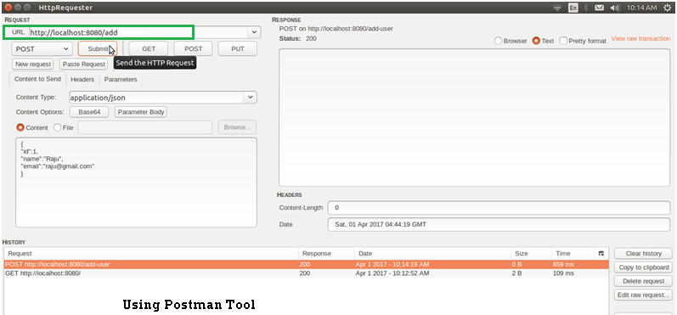

JpaRepository
JpaRepository provides some JPA related method such as flushing the persistence context and delete record in a batch. JpaRepository extends PagingAndSortingRepository which in turn extends CrudRepository.
Their main functions are:
- CrudRepository mainly provides CRUD functions.
- PagingAndSortingRepository provide methods to do pagination and sorting records.
- JpaRepository provides some JPA related method such as flushing the persistence context and delete record in a batch.
Because of the inheritance mentioned above, JpaRepository will have all the functions of CrudRepository and PagingAndSortingRepository.

Custom Queries
Spring Data JPA provides three different approaches for creating custom queries with query methods. Each of these approaches is described in following.

Using Method Name
- Spring Data JPA has a built in query creation mechanism which can be used for parsing queries straight from the method name of a query method.
- the method names of your repository interface are created by combining the property names of an entity object and the supported keywords.
public interface PersonRepository extends Repository<User, Long> {

List<Person> findByEmailAddressAndLastname(EmailAddress emailAddress, String lastname);

// Enables the distinct flag for the query
List<Person> findDistinctPeopleByLastnameOrFirstname(String lastname, String firstname);
List<Person> findPeopleDistinctByLastnameOrFirstname(String lastname, String firstname);

// Enabling ignoring case for an individual property
List<Person> findByLastnameIgnoreCase(String lastname);

// Enabling ignoring case for all suitable properties
List<Person> findByLastnameAndFirstnameAllIgnoreCase(String lastname, String firstname);

// Enabling static ORDER BY for a query
List<Person> findByLastnameOrderByFirstnameAsc(String lastname);
List<Person> findByLastnameOrderByFirstnameDesc(String lastname);
}

JPA Named Queries
Spring Data JPA provides also support for the JPA Named Queries. You have got following alternatives for declaring the named queries:
- You can use either named-query XML element or @NamedQuery annotation to create named queries with the JPA query language.
- You can use either named-native-query XML element or @NamedNative query annotation to create queries with SQL if you are ready to tie your application with a specific database platform.
The only thing you have to do to use the created named queries is to name the query method of your repository interface to match with the name of your named query. See below Example code
@Entity
@NamedQuery(name = "Person.findByName", query = "SELECT p FROM Person p WHERE LOWER(p.lastName) = LOWER(?1)")
@Table(name = "persons")
public class Person {

@Id
@GeneratedValue(strategy = GenerationType.AUTO)
private Long id;

@Column(name = "creation_time", nullable = false)
private Date creationTime;

@Column(name = "first_name", nullable = false)
private String firstName;
}

The relevant part of my PersonRepository interface looks following
public interface PersonRepository extends JpaRepository<Person, Long> {
//A list of persons whose last name is an exact match with the given last name.
public List<Person> findByName(String lastName);
}

@Query Annotation
- The @Query annotation can be used to create queries by using the JPA query language and to bind these queries directly to the methods of your repository interface.
- When the query method is called, Spring Data JPA will execute the query specified by the @Query annotation
- If there is a collision between the @Query annotation and the named queries, the query specified by using @Query annotation will be executed
public interface ProductRepository
extends CrudRepository<Product, Long> {
@Query("FROM Product")
List<Product> findAllProducts();
}

You may use positional parameters instead of named parameters in queries. Positional parameters are prefixed with a question mark (?) followed the numeric position of the parameter in the query. The Query.setParameter(integer position, Object value) method is used to set the parameter values.
public List findWithName(String name) {
return em.createQuery(
“SELECT c FROM Customer c WHERE c.name LIKE ?1”)
.setParameter(1, name)
.getResultList();
}

Automatic Query Generation
The <jpa:repositories/> has an option query-lookup-strategy which defaults to “create-if-not-found” which will generate queries for us.The default is “create-if-not-found“. Other options are “create” or “use-declared-query“.
<jpa:repositories base-package="com.gordondickens.myapp.repository"
query-lookup-strategy="create-if-not-found"/>

To create a find method that effectively does @Query("FROM Product p where p.productId =:productId")
public interface ProductRepository extends CrudRepository<Product, Long> {
...

@Query
Product findByProductId(String productId);

...

Example
Student.java
package app.entity;

@Entity
@Table(name = "student")
public class Student {

@Id
@GeneratedValue(strategy = GenerationType.AUTO)
private int sno;

@Column(name = "name")
private String name;

@Column(name = "address")
private String address;

@Override
public String toString() {
String str = "Student[" + "Sno: " + getSno() + ", Name:" + getName() + ", " + "Address : " + getAddress() + "]";
return str;
}
//Setters & getters
}

StudentRepository.java
public interface StudentRepository extends CrudRepository<Student, Long> {

List<Student> findBySno(int sno);

List<Student> findByName(String name);

// custom query example and return a stream
@Query("select c from Student c where c.address = :address")
Stream<Student> findByAddress(@Param("address") String address);
}

Application.java
package app;
@SpringBootApplication
public class Application implements CommandLineRunner {

@Autowired
DataSource dataSource;

@Autowired
StudentRepository repository;

public static void main(String[] args) throws Exception {
SpringApplication.run(Application.class, args);
}

@Transactional(readOnly = true)
@Override
public void run(String... args) throws Exception {

System.out.println("DATASOURCE = " + dataSource);

System.out.println("\n1.findAll()...");
for (Student student : repository.findAll()) {
System.out.println(student);
}

System.out.println("\n2.findByName(String name)...");
for (Student student : repository.findByName("Satya")) {
System.out.println(student);
}

System.out.println("\n3.findByAddress(@Param(\"name\"))...");
try (Stream<Student> s =repository.findByAddress("Vijayawada")) {
s.forEach(x -> System.out.println(x));
System.out.println("Done!");
exit(0);
}
}
}
1.findAll()...
Student[Sno: 0, Name:null, Address : null]
Student[Sno: 101, Name:Satya, Address : VIJAYAWADA]
Student[Sno: 102, Name:Satya, Address : Vijayawada]
Student[Sno: 147, Name:kumar, Address : Hyderabad]
Student[Sno: 189, Name:Satya, Address : Vijayawada]
Student[Sno: 508, Name:Satya, Address : Hyd]

2.findByName(String name)...
Student[Sno: 101, Name:Satya, Address : VIJAYAWADA]
Student[Sno: 102, Name:Satya, Address : Vijayawada]
Student[Sno: 189, Name:Satya, Address : Vijayawada]
Student[Sno: 508, Name:Satya, Address : Hyd]

4.findByAddress(@Param("name") String name)...
Student[Sno: 101, Name:Satya, Address : VIJAYAWADA]
Student[Sno: 102, Name:Satya, Address : Vijayawada]
Student[Sno: 189, Name:Satya, Address : Vijayawada]

Spring Boot –MongoDB REST Example
Configuration file application.properties
# Create new database : ‘smlcodes’
spring.data.mongodb.database=smlcodes
spring.data.mongodb.host=localhost
spring.data.mongodb.port=27017

we need to model our documents. Let’s call ours ‘Booking’ and give it a make, model, and description. Here is our Java class to accomplish this
package smlcodes.repository;
import org.springframework.data.annotation.Id;
import org.springframework.data.mongodb.core.mapping.Document;

@Document
public class Student{

@Id
String sno;
String name;
String address;
public String getSno() {
return sno;
}
public void setSno(String sno) {
this.sno = sno;
}
public String getName() {
return name;
}
public void setName(String name) {
this.name = name;
}
public String getAddress() {
return address;
}
public void setAddress(String address) {
this.address = address;
}
}
- @Id- id provided by Mongo for a document.
- @Document- provides a collection name.
BookingRepository.java
The MongoRepository provides basic CRUD operation methods and also an API to find all documents in the collection.
@Transactional
public interface StudentRepository extends MongoRepository<Student, String> {
public Student findBySno(int sno);
}

BookingController.java
package smlcodes.controller;

@RestController
@RequestMapping("/student")
public class StudentController {

@Autowired
StudentRepository studentRepository;

@RequestMapping("/create")
public Map<String, Object> create(Student student) {
student = studentRepository.save(student);
Map<String, Object> dataMap = new HashMap<String, Object>();
dataMap.put("message", "Student created successfully");
dataMap.put("status", "1");
dataMap.put("student", student);
return dataMap;
}

@RequestMapping("/read")
public Map<String, Object> read(@RequestParam int sno) {
Student student = studentRepository.findBySno(sno);
Map<String, Object> dataMap = new HashMap<String, Object>();
dataMap.put("message", "Student found successfully");
dataMap.put("status", "1");
dataMap.put("student", student);
return dataMap;
}

@RequestMapping("/readall")
public Map<String, Object> readAll() {
List<Student> students = studentRepository.findAll();
Map<String, Object> dataMap = new HashMap<String, Object>();
dataMap.put("message", "Student found successfully");
dataMap.put("totalStudent", students.size());
dataMap.put("status", "1");
dataMap.put("students", students);
return dataMap;
}
}

SpringBootMongoDbApplication.java
@SpringBootApplication
public class SpringBootMongoDbApplication {
public static void main(String[] args) {
SpringApplication.run(SpringBootMongoDbApplication.class, args);
}
}

Test
http://localhost:8080/student/create?sno=101&name=Satya&address=HYDERABAD 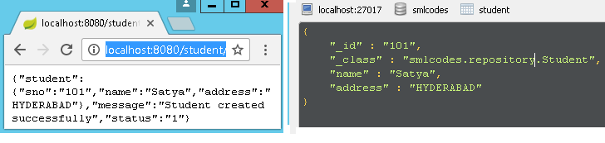

Spring Missing/ Confusing Topics

Diffrence between @Component & @Autowire
@Compoent is just creating bean object of that class at Auto Scanning time.
@Autowire is, after creating bean object in @Componet time, it will autowires/ injecets the Dependent classes.

Diffrence beteen @ComponentScan & @Enable AutoCOnfiguration
One of the main advantages of Spring Boot is its annotation driven versus traditional xml based configurations, @EnableAutoConfiguration automatically configures the Spring application based on its included jar files, it sets up defaults or helper based on dependencies in pom.xml. Auto-configuration is usually applied based on the classpath and the defined beans. Therefore, we donot need to define any of the DataSource, EntityManagerFactory, TransactionManager etc and magically based on the classpath, Spring Boot automatically creates proper beans and registers them for us. For example when there is a tomcat-embedded.jar on your classpath you likely need a TomcatEmbeddedServletContainerFactory (unless you have defined your own EmbeddedServletContainerFactory bean). @EnableAutoConfiguration has a exclude attribute to disable an auto-configuration explicitly otherwise we can simply exclude it from the pom.xml, for example if we donot want Spring to configure the tomcat then exclude spring-bootstarter-tomcat from spring-boot-starter-web.
@ComponentScan provides scope for spring component scan, it simply goes though the provided base package and picks up dependencies required by @Bean or @Autowired etc, In a typical Spring application, @ComponentScan is used in a configuration classes, the ones annotated with @Configuration. Configuration classes contains methods annotated with @Bean. These @Bean annotated methods generate beans managed by Spring container. Those beans will be auto-detected by @ComponentScan annotation. There are some annotations which make beans auto-detectable like @Repository , @Service, @Controller, @Configuration, @Component. In below code Spring starts scanning from the package including BeanA class.

AngularJS with SpringBoot
AngularJs is a Single page application. That means we have only index.html file, but we can change the views in single page.
Index.html
<body ng-app="">
….
<div ng-view="">
// we can change the views as per controller logic display view
</div>
….
<body>

SpringBoot App UI
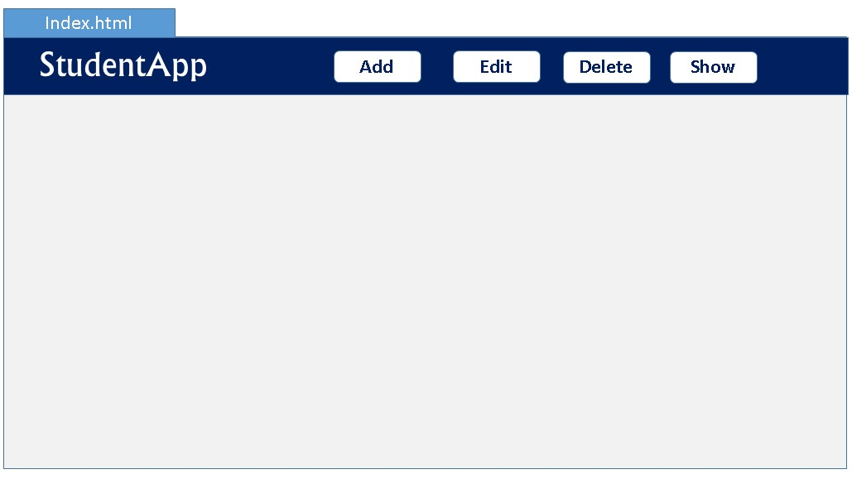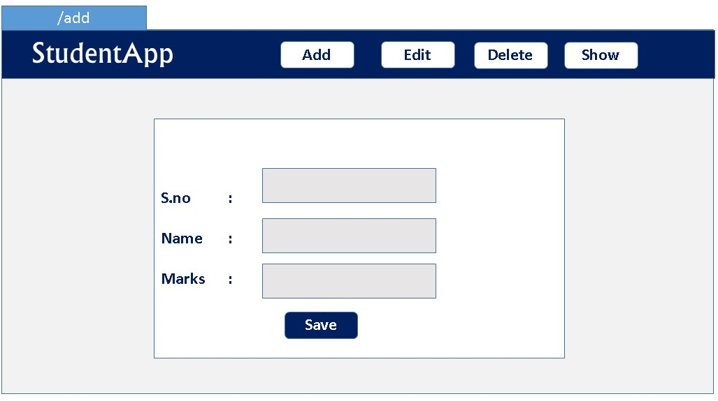
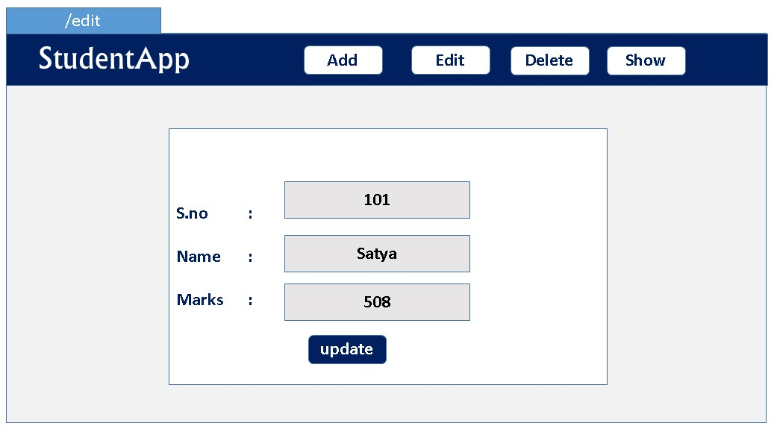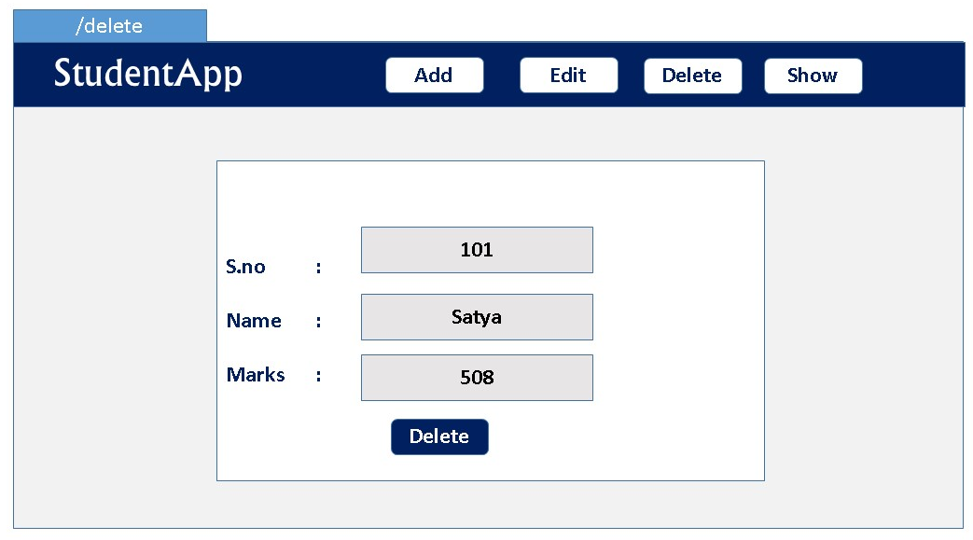
Before going to the implementation, we need to know Basics once.

Basics
AngularJS extends HTML attributes with Directives, and binds data to HTML with Expressions.
AngularJS is distributed as a JavaScript file, and can be added to a web page with a script tag:
<script src="https://ajax.googleapis.com/ajax/libs/angularjs/1.6.9/angular.min.js"></script>
- The ng-app directive defines an AngularJS application.
- The ng-model directive binds the value of HTML controls (input, select, textarea) to application data.
- The ng-bind directive binds application data to the HTML view
- {{ expression }}. expressions bind AngularJS data to HTML the same way as the ng-bind directive
<div ng-app="">
<p>Name: <input type="text" ng-model="name"></p>
<p ng-bind="name"></p>
<p>{{name}} </p> //will print the same
</div>

Understand with Example
AngularJS Example : index.html
<div ng-app="myApp" ng-controller="myCtrl">
First Name: <input type="text" ng-model="firstName"><br> //binds input with model
Last Name: <input type="text" ng-model="lastName"><br> ////binds input with model
Full Name: {{firstName + " " + lastName}} //Prints the model values
</div>
<script>
var app = angular.module('myApp', []);
app.controller('myCtrl', function($scope) {
$scope.firstName= "John";
$scope.lastName= "Doe";
});
</script>

1.ng-app
- The ng-app directive tells AngularJS that this is the root element of the AngularJS application.
- All AngularJS applications must have a root element.
- You can only have one ng-app directive in your HTML document. If more than one ng-app directive appears, the first appearance will be used
In index.html. We will have to tell Angular in which part of the application it should be active.
You saw that when declaring the angular module, we named it app. To tell it where it should be active we add the attribute ng-app="app" in the tag and everything inside of it turns into an AngularJS application.
In our case, as the whole page will be an ngapp it is better to place the attribute in the <html> tag or in the <body> tag.

2.ng-controller
The ngController directive specifies a Controller class; the class contains business logic behind the application to decorate the scope with functions and values.
In above 'myCtrl'has following business logic
app.controller('myCtrl', function($scope) {
$scope.firstName= "John";
$scope.lastName= "Doe";
});
3.angular.module
The angular.module is a global place for creating, registering and retrieving AngularJS modules. All modules (AngularJS core or 3rd party) that should be available to an application must be registered using this mechanism.
var app = angular.module('myApp', []);
in this line we registred the module with variable ‘app’. Now we can access this module in whole application with variable name to perform any kind of operations.

3.$scope
- $scope is a Global Object which can accessed by both view and controller.
- When adding properties to the $scope object in the controller, the view (HTML) gets access to these properties
- All applications have a $rootScope which is the scope created on the HTML element that contains the ng-app directive.
- The rootScope is available in the entire application.

AngularJs internal working
Now you will take a look at the architecture concepts of AngularJS. When an HTML document is loaded into the browser and is evaluated by the browser, the following happens:
- The AngularJS JavaScript file is loaded, and the Angular global object$scope is created. The JavaScript file that registers the controller functions is executed.

- AngularJS scans the HTML to look for AngularJS apps and views and finds a controller function corresponding to the view.

- AngularJS executes the controller functions and updates the views with data from the model populated by the controller.

- AngularJS listens for browser events, such as button clicked, mouse moved, input field being changed, and so on. If any of these events happen, then AngularJS will update the view accordingly
Bootstrapping AngularJS by Adding ng-app in an HTML Page
<html lang="en" ng-app="userregistrationsystem">...</html>
This is also known as automatic initialization. So, when AngularJS finds the ng-app directive after analyzing the index.html file, it loads the associated modules and then compiles the DOM.

Few More Examples
AngularJS Example : ng-init, {{ expression }} = ng-bind
<div ng-app="" ng-init="firstName='John';lastName='Doe'">
<p>The name is {{ firstName + " " + lastName }}</p>
<p>The name is <span ng-bind="firstName + ' ' + lastName"></span></p>
</div>

AngularJS Objects
AngularJS objects are like JavaScript objects:
<div ng-app="" ng-init="person={firstName:'John',lastName:'Doe'}">
<p>The name is {{ person.lastName }}</p> //or
<p>The name is <span ng-bind="person.lastName"></span></p>
</div>

AngularJS Arrays
AngularJS arrays are like JavaScript arrays:
<div ng-app="" ng-init="points=[1,15,19,2,40]">
<p>The third result is {{ points[2] }}</p>
</div>

AngularJS Module
- Creating a Module
<div ng-app="myApp">...</div>
<script>
var app = angular.module("myApp", []);
</script>
- Adding a Controller
<script>
var app = angular.module("myApp", []);
app.controller("myCtrl", function($scope) {
$scope.firstName = "John";
$scope.lastName = "Doe";
});
</script>

AngularJS Filters
AngularJS provides filters to transform data:
- uppercase Format a string to upper case.
<p>The name is {{ lastName | uppercase }}</p>
- lowercase Format a string to lower case.
<p>The name is {{ lastName | lowercase }}</p>
- orderBy Orders an array by an expression.
<ul>
<li ng-repeat="x in names | orderBy:'country'">
{{ x.name + ', ' + x.country }}
</li>
</ul>

AngularJS Services
- In AngularJS, a service is a function, or object, that is available for your AngularJS application.
- AngularJS has about 30 built-in services. One of them is the $location service.
1.$location
returns information about the location of the current web page:
var app = angular.module('myApp', []);
app.controller('customersCtrl', function($scope, $location) {
$scope.myUrl = $location.absUrl();
});
{{myUrl}} //prints https://www.w3schools.com/angular/tryit.asp?filename=try_ng_services
$2.$http
$http is an AngularJS service for reading data from remote servers. The AngularJS $http service makes a request to the server, and returns a response.
var app = angular.module('myApp', []);
app.controller('myCtrl', function($scope, $http) {
$http.get("welcome.htm").then(function (response) {
$scope.myWelcome = response.data;
});
});
More on Http
The example above uses the .get method of the $http service.
The .get method is a shortcut method of the $http service. There are several shortcut methods:
- .get()
- .post()
- .put()
- .delete()
- .head()
- .jsonp()
- .patch()
var app = angular.module('myApp', []);
app.controller('myCtrl', function($scope, $http) {
$http({
method : "GET",
url : "welcome.htm"
}).then(function mySuccess(response) {
$scope.myWelcome = response.data;
}, function myError(response) {
$scope.myWelcome = response.statusText;
});
});

Responnse Types
- .config the object used to generate the request.
- .data a string, or an object, carrying the response from the server.
- .headers a function to use to get header information.
- .status a number defining the HTTP status.
- .statusText a string defining the HTTP status.
<div ng-app="myApp" ng-controller="myCtrl">
<p>Data : {{content}}</p>
<p>Status : {{statuscode}}</p>
<p>StatusText : {{statustext}}</p>
</div>
var app = angular.module('myApp', []);
app.controller('myCtrl', function($scope, $http) {
$http.get("welcome.htm")
.then(function(response) {
$scope.content = response.data;
$scope.statuscode = response.status;
$scope.statustext = response.statusText;
});
});
Data : Hello AngularJS Students
Status : 200
StatusText :

AngularJS Events
You can add AngularJS event listeners to your HTML elements by using one or more of these directives:ng-blur
- ng-change
- ng-click
- ng-dblclick
- ng-focus
- ng-keydown
- ng-keypress
- ng-keyup
- ng-mousedown
- ng-mouseenter
- ng-mouseleave
Increase the count variable when the mouse clicked.
<div ng-app="myApp" ng-controller="myCtrl">
<button ng-click="count = count + 1">Click me!</button>
<p>{{ count }}</p>
</div>
//At Start count is 0 once Js load
<script>
var app = angular.module('myApp', []);
app.controller('myCtrl', function($scope) {
$scope.count = 0;
});
</script>

AngularJS Routing
The ngRoute module helps your application to become a Single Page Application.
- If you want to navigate to different pages in your application, but you also want the application to be a SPA (Single Page Application), with no page reloading, you can use the ngRoute module.

- The ngRoute module routes your application to different pages without reloading the entire application.

For doing this
- you must include the AngularJS Route module JS
<script src="https://ajax.googleapis.com/angular-route.js"></script>
- Then you must add the ngRoute as a dependency in the application module:
var app = angular.module("myApp", ["ngRoute"]);
- Now your application has access to the route module, which provides the $routeProvider. Use the $routeProvider to configure(app.config) different routes in your application:
app.config(function($routeProvider) {
$routeProvider
.when("/", {
templateUrl : "main.htm"
})
.when("/red", {
templateUrl : "red.htm"
})
.when("/green", {
templateUrl : "green.htm"
})
.when("/blue", {
templateUrl : "blue.htm"
});
});

Example
<body ng-app="myApp">
<a href="#/!">Main</a></p>
<a href="#!red">Red</a>
<a href="#!green">Green</a>
<a href="#!blue">Blue</a>
<div ng-view>
<! —HERE CONTENT CHANGES -->
</div>
<script>
var app = angular.module("myApp", ["ngRoute"]);
app.config(function($routeProvider) {
$routeProvider
.when("/", {
templateUrl : "main.htm"
})
.when("/red", {
templateUrl : "red.htm"
})
.when("/green", {
templateUrl : "green.htm"
})
.when("/blue", {
templateUrl : "blue.htm"
});
});
</script>
</body>

AngularJS Architecture Concepts
Now you will take a look at the architecture concepts of AngularJS. When an HTML document is loaded into the browser and is evaluated by the browser, the following happens:
- The AngularJS JavaScript file is loaded, and the Angular global object$scope is created. The JavaScript file that registers the controller functions is executed.
- AngularJS scans the HTML to look for AngularJS apps and views and finds a controller function corresponding to the view.
- AngularJS executes the controller functions and updates the views with data from the model populated by the controller.
- AngularJS listens for browser events, such as button clicked, mouse moved, input field being changed, and so on. If any of these events happen, then AngularJS will update the view accordingly
Bootstrapping AngularJS by Adding ng-app in an HTML Page
<html lang="en" ng-app="userregistrationsystem">...</html>
This is also known as automatic initialization. So, when AngularJS finds the ng-app directive after analyzing the

AngularJs + SpringBoot Example implementation
Index.html
- Create index.html & add all Anuglar related jars
- Declare body ng-app="stApp"> which will be the Startig point of our AngularJs App
- Create module
var app = angular.module("myApp", []);
if no dependencies are there [ ] will be empty
<body ng-app="stApp">

<nav class="navbar navbar-inverse">
ADD, EDIT, DELETE etc
</nav>

<div class="container">
<h1>Student Application</h1>
</div>

</body>
</html>

Integration Testing
Integration testing is all about testing all pieces of an application working together as they would in a live or production environment
To convert any JUnit test into a proper integration test, there are really two basic things that you need to do.
- The first is you need to annotate your tests with the @RunWith annotation and specify that you want to run it with the SpringJUnit4ClassRunner.class
- The second is you need to add the @SpringApplicationConfiguration annotation and provide your main Spring Boot class for your application.
@RunWith(SpringJUnit4ClassRunner.class)
@SpringApplicationConfiguration(Demo.class)
public class UserRepoIntegrationTest {
@Autowired
private UserRepository userRepository;

@Test
public void testFindAll() {
List<User> users = userRepository.findAll();
assertThat(users.size(), is(greaterThanOrEqualTo(0)));
}
}
Regardless of the test result - successful or unsuccessful, open your IDE Console tab and you should notice that it looks like your application started (Spring logo, info etc). This happens because our application actually starts with integration tests

MockMvc
Spring MockMVC to perform integration testing of spring webmvc controllers
MockMVC class is part of Spring MVC test framework which helps in testing the controllers explicitly starting a Servlet container.
@RunWith(SpringRunner.class)
@WebMvcTest(StudentController.class)
public class StudentIntegrationTests {

@Autowired
private MockMvc mvc;
}
- SpringRunner is an alias for the SpringJUnit4ClassRunner.
- @WebMvcTest annotation is used for Spring MVC tests. It disables full auto-configuration and instead apply only configuration relevant to MVC tests.
- StudentController.class means initialize only this controller and provide dependent Mock object of this controller.
MockMvcRequestBuilders -hit the APIs & passing the path parameters and verify the status response codes
MockMvcResultMatchers – get the response content & matches with expected content

Types of Authentication
A servlet-based web application can choose from the following types of authentication, from least secure to most:
- Basic authentication
- Form-based authentication
- Digest authentication
- SSL and client certificate authentication
“Authentication” and “Authorization”. Authentication can be defined as the process of verifying someone’s identity by using pre-required details (Commonly username and password). Authorization is the process of allowing an authenticated user to access a specified resource (eg:-right to access a file).

HTTP Basic Authentication
- One solution is that of HTTP Basic Authentication. In this approach, an HTTP user agent simply provides a usernameand password to prove their authentication.
- This approach does not require cookies, session IDs, login pages, and other such specialty solutions, and because it uses the HTTP header itself, there’s no need to handshakes or other complex response systems.
- HTTP is not encrypted in any way. It is encapsulated in base64, and is often erroneously proclaimed as encrypted due to this

Digest authentication
The difference between digest authentication and basic authentication is that in digest authentication, the username and password are never sent over the wire. Instead, a hash is created made up of the following pieces of information:
- The username
- The password
- The URL
- The randomly generated string (the nonce)
- The HTTP method being used

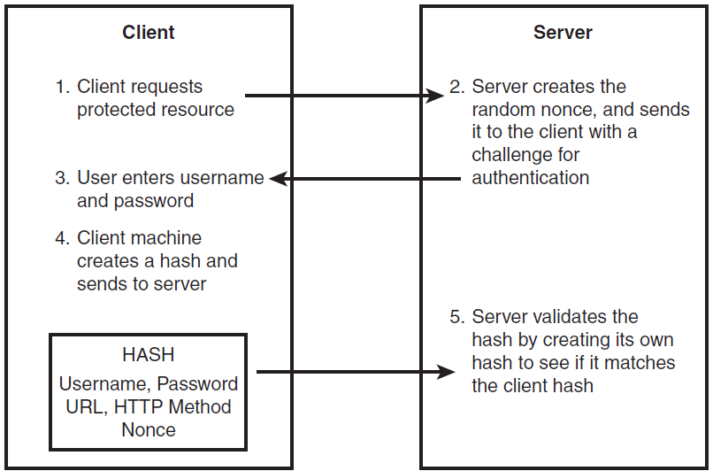

API Keys : for Developer Quickstart
- To access Bitbucket in Hygieia, we will generate API key, and we will place that key in properties file.
- API Keys can be used as Basic HTTP Authentication credentials and provide a substitute for the account's actual username and password.
- The best thing about an API key is its simplicity. You merely log in to a service, find your API key (often in the settings screen), and copy it to use in an application, test in the browser, or use with one of these API request tools
- Typically, an API key gives full access to every operation an API can perform, including writing new data or deleting existing data. If you use the same API key in multiple apps, a broken app could destroy your users' data without an easy way to stop just that one app.
- Many API keys are sent in the query string as part of the URL, which makes it easier to discover for someone who should not have access to it. A better option is to put the API key in the Authorization header. In fact, that’s the proposed standard:
Authorization: Apikey 1234567890abcdef

OAuth Tokens: Great for Accessing User Data
- OAuth is the answer to accessing user data with APIs.
- users simply click a button to allow an application to access their accounts.
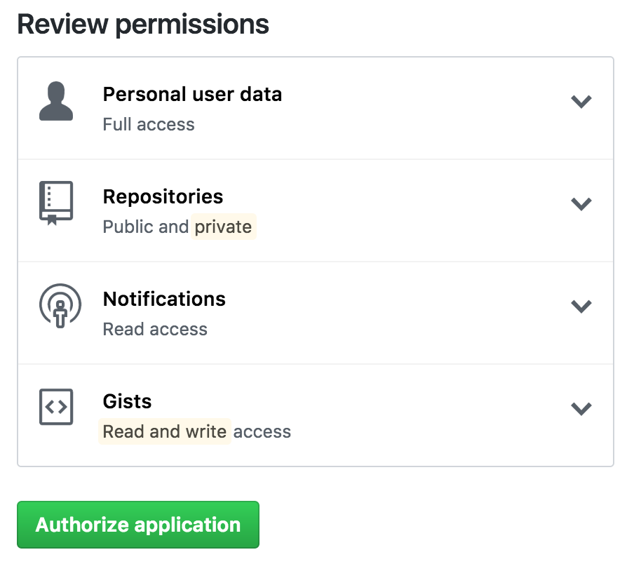

LDAP
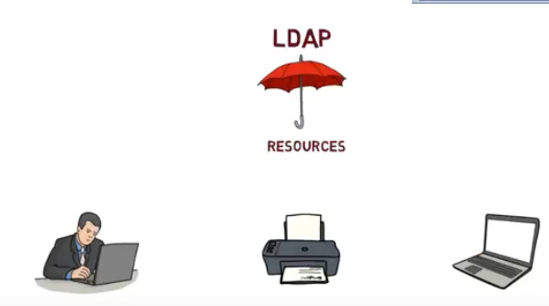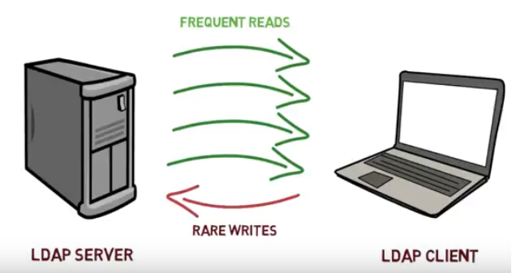

class Simple {
public static void main(String[] args) {
Hashtable authEnv = new Hashtable(11);
String userName = "johnlennon";
String passWord = "sushi974";
String base = "ou=People,dc=example,dc=com";
String dn = "uid=" + userName + "," + base;
String ldapURL = "ldap://ldap.example.com:389";

authEnv.put(Context.INITIAL_CONTEXT_FACTORY,"com.sun.jndi.ldap.LdapCtxFactory");
authEnv.put(Context.PROVIDER_URL, ldapURL);
authEnv.put(Context.SECURITY_AUTHENTICATION, "simple");
authEnv.put(Context.SECURITY_PRINCIPAL, dn);
authEnv.put(Context.SECURITY_CREDENTIALS, passWord);

try {
DirContext authContext = new InitialDirContext(authEnv);
System.out.println("Authentication Success!");
} catch (AuthenticationException authEx) {
System.out.println("Authentication failed!");
} catch (NamingException namEx) {
System.out.println("Something went wrong!");
namEx.printStackTrace();
}
}
}

SSH – Only for LINUX Server / CommadLine(git) related Access
- SSH, or secure shell, is an encrypted protocol used to administer and communicate with servers. When working with a Linux server, chances are, you will spend most of your time in a terminal session connected to your server through SSH.
- An SSH server can authenticate clients using a variety of different methods. The most basic of these is password authentication, which is easy to use, but not the most secure.
- SSH key pairs are two cryptographically secure keys that can be used to authenticate a client to an SSH server. Each key pair consists of a public key and a private key.
- The private key is retained by the client and should be kept absolutely secret. Any compromise of the private key will allow the attacker to log into servers that are configured with the associated public key without additional authentication. As an additional precaution, the key can be encrypted on disk with a passphrase.
- The associated public key can be shared freely without any negative consequences. The public key can be used to encrypt messages that only the private key can decrypt. This property is employed as a way of authenticating using the key pair.
- The public key is uploaded to a remote server that you want to be able to log into with SSH. The key is added to a special file within the user account you will be logging into called ~/.ssh/authorized_keys.
- When a client attempts to authenticate using SSH keys, the server can test the client on whether they are in possession of the private key. If the client can prove that it owns the private key, a shell session is spawned or the requested command is executed.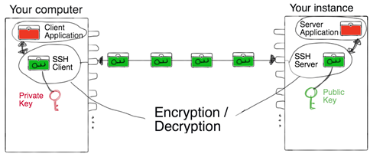

Base64 – not Authentication
represent binary data in an ASCII string format
Each Base64 digit represents exactly 6 bits of data.
Steps:
- take three ASCII numbers 155, 162, and 233
- Convert into binary stream formate 100110111010001011101001
- groupings of six characters: 100110 111010 001011 101001.
- The binary string 100110 converts to the decimal number 38: 0*2^01 + 1*2^1 + 1*2^2 + 0*2^3 + 0*2^4 + 1*2^5 = 0+2+4+0+0+32.
- Base64 6-bit values 38, 58, 11 and 41.
- Using the Base64 conversion table:
  - 38 is m
  - 58 is 6
  - 11 is L
  - 41 is p

Help.html

StudentApp Document
1. Add Maven Dependency: spring-boot-starter-data-mongodb
2.Create Sudent Collection
>use student
>db.createCollection("student");
>db.student.insert(
{
sno: 501,
name: "Satya Kaveti",
city:"Vijayawada",
marks:508
}
)

3.in application.propertis , add Mongo DB details
spring.data.mongodb.database=student
spring.data.mongodb.port=27017
spring.data.mongodb.host=localhost
2.Create StudentModel.java with @Document & Id annotations
3.create StudentMongoRepository extends MongoRepository
4.Create StudentMongoController.java
How can Spring Boot work without driver configuration?
Spring Boot gives you defaults on all things, the default in database is H2, so when you want to change this and use any other database you must define the connection attributes in the application.properties file.
- H2 is one of the popular in memory databases. Spring Boot has default integration for H2
- is live only during the time of execution of the application, not for real world applications
- The h2-*.jar is just an engine (the code) of the database. It is read-only and it does not store any information. The data in H2 can be stored either in memory or on disk in a specified file. You are actually specifying one:
In our Application we are using MySQL, so we provided details with out Driver detilas
spring.datasource.url = jdbc:mysql://localhost:3306/student?useSSL=false
spring.datasource.username = root
spring.datasource.password = root

<dependency>
<groupId>org.springframework.boot</groupId>
<artifactId>spring-boot-starter-data-jpa</artifactId>
</dependency>

<dependency>
<groupId>mysql</groupId>
<artifactId>mysql-connector-java</artifactId>
<scope>runtime</scope>
</dependency>
- @EnableAutoConfiguration : This annotation tells Spring to automatically configure your application based on the dependencies that you have added in the pom.xml file.

- For example, If spring-data-jpa or spring-jdbc is in the classpath, then it automatically tries to configure a DataSource by reading the database properties from application.properties file.

- So,in above we just have to add the configuration and Spring Boot will take care of the rest.

- In the above properties file, the last two properties are for hibernate. Spring Boot uses Hibernate as the default JPA implementation.

- If you remove mysql-connector-java from pom.xml, SpringBoot unable to find the MySQL related java classes in insert application.propeties values to create datasource, it will throw below error.
Failed to bind properties under '' to com.zaxxer.hikari.HikariDataSource:
Property: driverclassname
Value: com.mysql.cj.jdbc.Driver
Origin: "driverClassName" from property source "source"
Reason: Failed to load driver class com.mysql.cj.jdbc.Driver in either of HikariConfig class loader or Thread context classloader

Action:
Update your application's configuration
So finally, SpringBoot uses Drivers & all normal stuff though @EnableAutoConfiguration to do the job

Spring Boot with multiple databases
In Our StudentApp we have multiple Databases.
1.if we use only one Database :MySQL we can use default spring.data.*properties. Spring @EnableAutoConfiguration will create Datasource by reading these properties
spring.datasource.url = jdbc:mysql://localhost:3306/student?useSSL=false
spring.datasource.username = root
spring.datasource.password = root

2.if we use two databases :MySQL, Mongo we can use default spring.data.*properties of therir respective databases. Spring @EnableAutoConfiguration will create two different Datasource by reading these properties
spring.data.mongodb.database=student
spring.data.mongodb.port=27017
spring.data.mongodb.host=localhost
3.If we use two DB’s with our own Config properties we need to Ovveride DataSource Manually
#----------- MySQL -------------
own.spring.mysql.datasource.url = jdbc:mysql://localhost:3306/student?useSSL=false
own.spring.mysql.datasource.username = root
own.spring.mysql.datasource.password = root

#----------- MongoDB -------------
own.spring.mongo.datasource.database=student
own.spring.mongo.datasource.port=27017
own.spring.mongo.datasource.host=localhost

Because we want the Spring Boot autoconfiguration to pick up those different properties (and actually instantiate two different DataSources), we need to instantiate our DataSource beans manually in a configuration class
@Configuration
public class MultipleDataSourceConfiguration {
@Bean
@Primary
@ConfigurationProperties(prefix="own.spring.mysql.datasource")
public DataSource primaryDataSource() {
return DataSourceBuilder.create().build();
}
@Bean
@ConfigurationProperties(prefix="own.spring.mongo.datasource")
public DataSource secondaryDataSource() {
return DataSourceBuilder.create().build();
}
}

@Conditional & @Profilers
While developing Spring based applications we may come across a need to register beans conditionally.
For example, you may want to register a DataSource bean pointing to the dev database abd different production database while running in production.
To address this problem, Spring 3.1 introduced the concept of Profiles. When you run the application you can activate the desired profiles ,and only those beans of that profiles will be registered.
@Configuration
public class AppConfig
{
@Bean
@Profile("DEV")
public DataSource devDataSource() {
...
}
@Bean
@Profile("PROD")
public DataSource prodDataSource() {
...
}
}
Then you can specify the active profile using System Property -Dspring.profiles.active=DEV

Now we can configure both JdbcUserDAO and MongoUserDAO beans conditionally using @Conditionalas follows:
@Configuration
public class AppConfig
{
@Bean
@Conditional(MySQLDatabaseTypeCondition.class)
public UserDAO jdbcUserDAO(){
return new JdbcUserDAO();
}
@Bean
@Conditional(MongoDBDatabaseTypeCondition.class)
public UserDAO mongoUserDAO(){
return new MongoUserDAO();
}
}

How EnableAutoConfiguration implemented?
auto-configuration is implemented with standard @Configuration classes. Additional @Conditional annotations are used to constrain when the auto-configuration should apply.

SpringBoot Security
spring-boot-starter-security: take care of all the required dependencies related to spring security.
<dependency>
<groupId>org.springframework.boot</groupId>
<artifactId>spring-boot-starter-security</artifactId>
</dependency>
This will include the SecurityAutoConfiguration class – containing the initial/default security configuration.
Just Run the project & see the magic
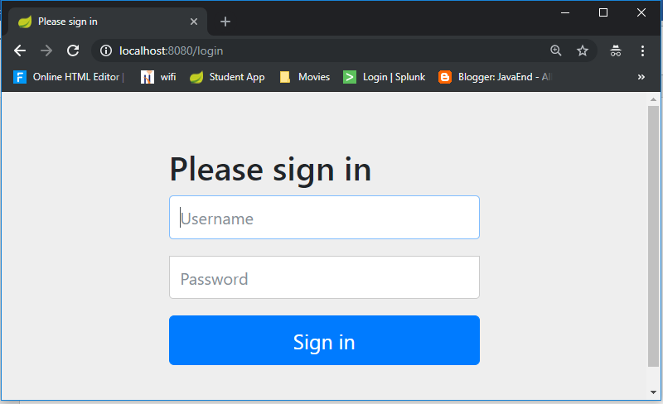
We never created this login form, but from where it came from?
SpringSecurity default comes with login page & you can login with generated password which is already printed in the console
Using generated security password: 8b4667a4-cc3a-47fd-b51f-b6f5e83745df
Def.user name is : user

You can change the password by providing a security.user.password. This and other useful properties are externalized via SecurityProperties (properties prefix "security").
security.user.name=user
security.user.name=password
security.basic.enabled=true

To discard the security auto-configuration and add our own configuration, we need to exclude the SecurityAutoConfiguration class.
@SpringBootApplication(exclude = { SecurityAutoConfiguration.class })
public class SpringBootSecurityApplication {
public static void main(String[] args) {
SpringApplication.run(SpringBootSecurityApplication.class, args);
}
}

Or by adding some configuration into the application.properties file:
spring.autoconfigure.exclude=org.springframework.boot.autoconfigure.security.SecurityAutoConfiguration

If we disabling security auto-configuration, we need to provide our own configuration, by extends WebSecurityConfigurerAdapter
@Configuration
@EnableWebSecurity
public class SecurityConfig extends WebSecurityConfigurerAdapter {

@Override
public void configure(HttpSecurity http) throws Exception {
// It allows configuring web based security for specific http requests
http
.authorizeRequests()
.anyRequest().authenticated()
.and()
.formLogin()
.and()
.httpBasic();

/* ============ Custom login Page URL ==========
http
.authorizeRequests()
.antMatchers("/admin/**").hasRole("ADMIN")
.antMatchers("/anonymous*").anonymous()
.antMatchers("/login*").permitAll()
.anyRequest().authenticated()
.and()
.formLogin()
.loginPage("/login.html")
.loginProcessingUrl("/perform_login")
.defaultSuccessUrl("/homepage.html", true)
//.failureUrl("/login.html?error=true")
.failureHandler(authenticationFailureHandler())
.and()
.logout()
.logoutUrl("/perform_logout")
.deleteCookies("JSESSIONID")
.logoutSuccessHandler(logoutSuccessHandler());
*/
}

@Bean
@Override
public UserDetailsService userDetailsService() {
UserDetails user =
User.withDefaultPasswordEncoder()
.username("user")
.password("user")
.roles("USER")
.build();

return new InMemoryUserDetailsManager(user);
}

}

Let’s summarize what we did in order to add Spring Boot Security to his web app. To secure his web app,
- we added Spring Boot Security to the classpath.
- Once it was in the classpath, Spring Boot Security was enabled by default.
- Then customized the security by extending WebSecurityConfigurerAdapter and added his own configure and userDetailsServiceimplementation.
- http://localhost:8080/login?logout
- https://docs.spring.io/spring-security/site/docs/current/guides/html5/form-javaconfig.html
- https://examples.javacodegeeks.com/enterprise-java/spring/boot/spring-boot-security-example/

SpringBoot AOP
Actually we don’t have Spring AOP starter in Springboot, but we can integrate using traditional Spring Framework
<dependency>
<groupId>org.springframework</groupId>
<artifactId>spring-aop</artifactId>
<version>5.0.1.RELEASE</version>
<scope>compile</scope>
</dependency>
<dependency>
<groupId>org.aspectj</groupId>
<artifactId>aspectjweaver</artifactId>
<version>1.8.12</version>
<scope>compile</scope>
</dependency>
Applications are generally developed with multiple layers. A typical Java application has
- Web Layer - Exposing the services to outside world using REST or a web application
- Business Layer - Business Logic
- Data Layer - Persistence Logic
While the responsibilities of each of these layers are different, there are a few common aspects that apply to all layers
- Logging
- Security

In this example we are implementing Logging – we are trying to Log the all the Application flow like, what controller is calling, what method is executing on performing certain operation.
package app.aop;

@Aspect
@Configuration
public class StudentAOP {

private Logger logger = LoggerFactory.getLogger(this.getClass());

//What kind of method calls I would intercept
//execution(* PACKAGE.*.*(..))
//Weaving & Weaver
@Before("execution(* app.repository.*.*(..))")
public void before(JoinPoint joinPoint){
//Advice
logger.info(" \n \n====== @Before===== \t app.repository");
logger.info(" Allowed execution for {}", joinPoint);
logger.info(" ====== @Before===== \n \n");
}

@AfterReturning(value = "execution(* app.controller.*.*(..))",
returning = "result")
public void afterReturning(JoinPoint joinPoint, Object result) {
logger.info("\n \n ====== @AfterReturning ===== \t : app.controller ");
logger.info("{} returned with value {}", joinPoint, result);
logger.info(" ====== @AfterReturning ===== \n \n");
}

@After(value = "execution(* app.security.*.*(..))")
public void after(JoinPoint joinPoint) {
logger.info("\n \n ====== @After ===== \t : app.security");
logger.info("after execution of {}", joinPoint);
logger.info(" ====== @After ===== \n \n");
}

}

====== @After ===== : app.security
2019-02-10 22:50:12.232 INFO 8152 --- [ main] dentAOP$$EnhancerBySpringCGLIB$$bb027782 : after execution of execution(UserDetailsService app.security.SecurityConfig.userDetailsService())
2019-02-10 22:50:12.236 INFO 8152 --- [ main] dentAOP$$EnhancerBySpringCGLIB$$bb027782 : ====== @After =====

====== @AfterReturning ===== : app.controller
2019-02-10 22:43:58.212 INFO 2440 --- [nio-8080-exec-7] dentAOP$$EnhancerBySpringCGLIB$$45dcbfee : execution(List app.controller.StudentMongoController.getAllStudents()) returned with value [Student [sno=501, name=vinay, city=karnool, marks=545], Student [sno=502, name=VINOD, city=BNHGG, marks=456]]
2019-02-10 22:43:58.212 INFO 2440 --- [nio-8080-exec-7] dentAOP$$EnhancerBySpringCGLIB$$45dcbfee : ====== @AfterReturning =====

Getting all users.2019-02-10 22:43:58.248 INFO 2440 --- [nio-8080-exec-9] dentAOP$$EnhancerBySpringCGLIB$$45dcbfee :

====== @AfterReturning ===== : app.controller
2019-02-10 22:43:58.248 INFO 2440 --- [nio-8080-exec-9] dentAOP$$EnhancerBySpringCGLIB$$45dcbfee : execution(List app.controller.StudentMongoController.getAllStudents()) returned with value [Student [sno=501, name=vinay, city=karnool, marks=545], Student [sno=502, name=VINOD, city=BNHGG, marks=456]]
2019-02-10 22:43:58.248 INFO 2440 --- [nio-8080-exec-9] dentAOP$$EnhancerBySpringCGLIB$$45dcbfee : ====== @AfterReturning =====

Pointcut - Pointcut is the expression used to define when a call to a method should be intercepted. In the above example, "execution(* app.repository.*.*(..))" is the pointcut.
Advice - It is the logic that you would want to exceute when you intercept a method. In the above example, it is the code inside the before(JoinPoint joinPoint)method.
Aspect – is the Class we defiend, combination of on which method (Pointcut) and what to do (Advice) is called an Aspect.
Join Point - When the code is executed and the condition for pointcut is met, the advice is executed. The Join Point is a specific execution instance of an advice.
Weaver - Weaver is the framework which implements AOP - AspectJ or Spring AOP.

SpringBoot Acuator - Health check, Auditing, Metrics,Monitoring
Actuator brings production-ready features to our application.
Monitoring our app, gathering metrics, understanding traffic or the state of our database becomes trivial with this dependency.
<dependency>
<groupId>org.springframework.boot</groupId>
<artifactId>spring-boot-starter-actuator</artifactId>
</dependency>
Once above maven dependency is included in the POM file, 16 different actuator REST endpoints, such as actuator, beans, dump, info, loggers, and metrics are exposed

Some of important and widely used actuator endpoints are given below:
ENDPOINT | USAGE
/env | Returns list of properties in current environment
/health | Returns application health information.
/auditevents | Returns all auto-configuration candidates and the reason why they ‘were’ or ‘were not’ applied.
/beans | Returns a complete list of all the Spring beans in your application.
/trace | Returns trace logs (by default the last 100 HTTP requests).
/dump | It performs a thread dump.
/metrics | It shows metrics information like JVM memory used, system CPU usage, open files, and much more.

You can access all avaible endpoint by this URL: http://localhost:8080/actuator
{
"_links": {
"self": {
"href": "http://localhost:8080/actuator",
"templated": false
},
"health": {
"href": "http://localhost:8080/actuator/health",
"templated": false
},
"health-component-instance": {
"href": "http://localhost:8080/actuator/health/{component}/{instance}",
"templated": true
},
"health-component": {
"href": "http://localhost:8080/actuator/health/{component}",
"templated": true
},
"info": {
"href": "http://localhost:8080/actuator/info",
"templated": false
}
}
}
If you see we have only 2 endpoints showing (health, info) out of 16 endpoints
By default, all the actuator endpoints are exposed over JMX but only the health and info endpoints are exposed over HTTP.

Here is how you can expose actuator endpoints over HTTP and JMX using application properties -
Exposing Actuator endpoints over HTTP
# Use "*" to expose all endpoints, or a comma-separated list to expose selected ones
management.endpoints.web.exposure.include=*
management.endpoints.web.exposure.exclude=

Exposing Actuator endpoints over JMX
# Use "*" to expose all endpoints, or a comma-separated list to expose selected ones
management.endpoints.jmx.exposure.include=*
management.endpoints.jmx.exposure.exclude=

Securing Actuator Endpoints with Spring Security
Actuator endpoints are sensitive and must be secured from unauthorized access. you can add spring security to your application using the following dependency -
<dependency>
<groupId>org.springframework.boot</groupId>
<artifactId>spring-boot-starter-security</artifactId>
</dependency>
we can override the default spring security configuration and define our own access rules.

Creating a Custom Actuator Endpoint
To customize the endpoint and define your own endpoint, simply Create a classs annotate with @Endpoint URL :
import org.springframework.boot.actuate.endpoint.annotation.Endpoint;
import org.springframework.boot.actuate.endpoint.annotation.ReadOperation;
import org.springframework.stereotype.Component;

@Endpoint(id="helloEndpoint")
@Component
public class ListEndPoints {
@ReadOperation
public String mypoint(){
return "Hello" ;
}
}
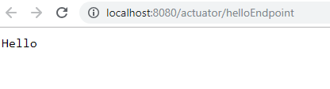
Few more Endpoints
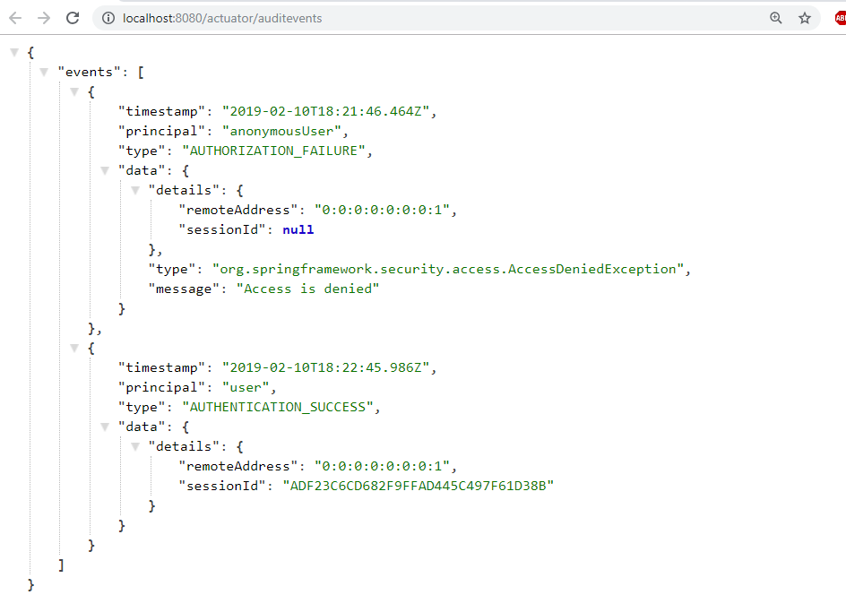

Spring cloud
Spring Cloud focuses on providing good out of box experience for typical use cases and extensibility mechanism to cover others.
- Distributed/versioned configuration
- Service registration and discovery
- Routing
- Service-to-service calls
- Load balancing
- Circuit Breakers
- Global locks
- Leadership election and cluster state
- Distributed messaging
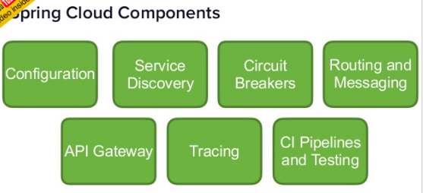
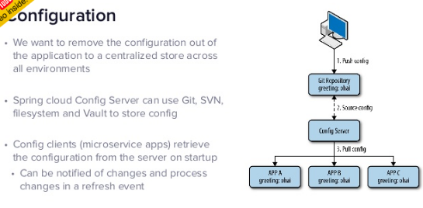
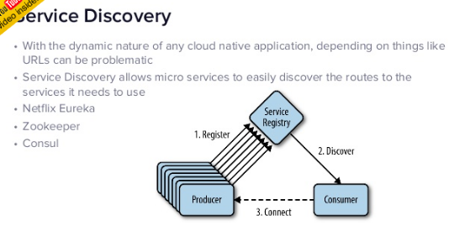
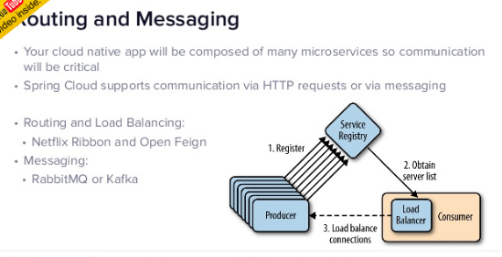
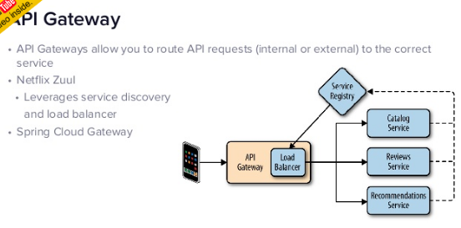

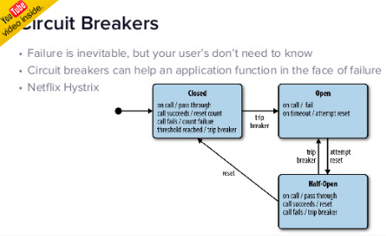
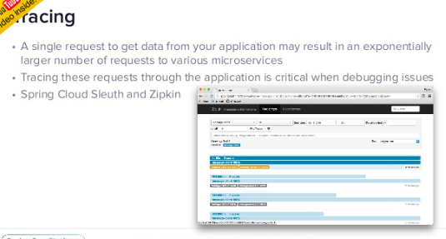
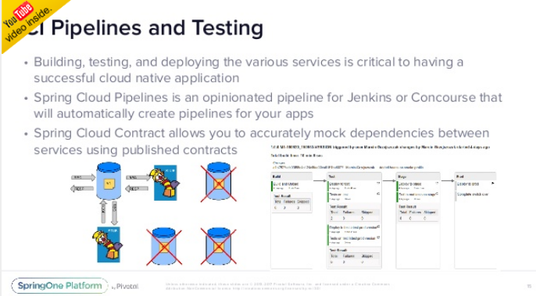
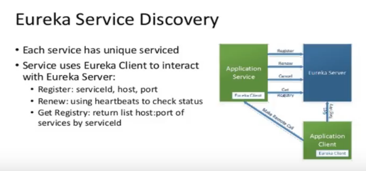
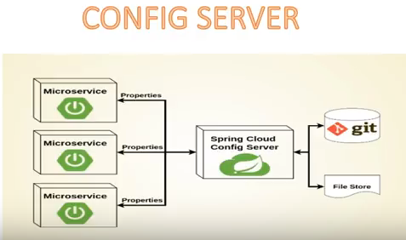

SpringBoot MicroServices
Microservices allows us to break our large system into the number of independent collaborating processes.
Shopping system without Microservices (Monolith architecture)
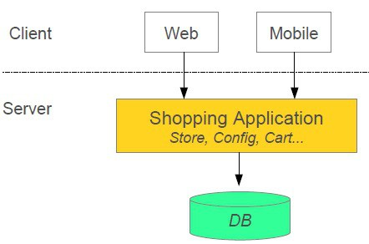
Shopping system with Microservices
In this architecture style, the main application divided into a set of sub-applications called microservices. One large Application divided into multiple collaborating processes as below.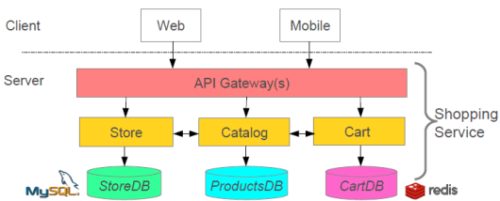

Microservices Benefits
- The smaller code base is easy to maintain.
- Easy to scale as an individual component.
- Technology diversity i.e. we can mix libraries, databases, frameworks etc.
- Fault isolation i.e. a process failure should not bring the whole system down.
- Better support for smaller and parallel team.
- Independent deployment
- Deployment time reduce

Microservices Challenges
- Distributed System so hard to debug and trace the issues
- Greater need for an end to end testing
- Required cultural changes in across teams like Dev and Ops working together even in the same team.

Microservices Tooling Supports
1. Use Spring for creating Microservices
- Setup new service by using Spring Boot
- Expose resources via a RestController
- Consume remote services using RestTemplat
2.Service Discovery
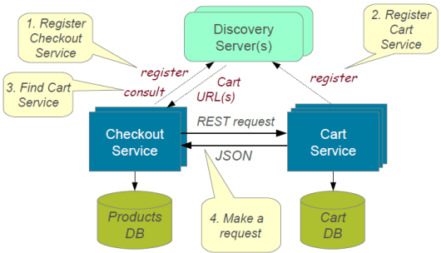
To build a simple microservices system following steps required
- Creating Discovery Service (Creating Eureka Discovery Service)
- Creating MicroService (the Producer), Register itself with Discovery Service with logical service.
3. Create Microservice Consumers find Service registered with Discovery ServiceDiscovery client using a smart RestTemplate to find microservice.

Example:
In this Example we have 3 Micro services should communicate each other.
Each micrpservice could have seprate Server & Separate DB
Discovery Server

Register Service
User
Server
Accounts
Server

1. Discovery Microservice server – To register microservice URLS
https://github.com/dineshonjava/discovery-microservice-server
@EnableEurekaServer –EurekaServer Acts as a Discovery Server. To Make our class as Discovery server use @EnableEurekaServer on the top of Spring Application class
@SpringBootApplication
@EnableEurekaServer
public class DiscoveryMicroserviceServerApplication {

public static void main(String[] args) {
SpringApplication.run(DiscoveryMicroserviceServerApplication.class, args);
}
}

Run this Eureka Server application with right click and run as Spring Boot Application and open in browser http://localhost:1111/
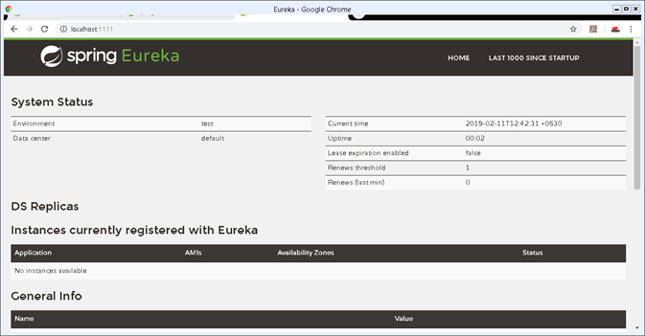

2. Accounts Microservice Server – It conatins Bank Account Deatils
https://github.com/dineshonjava/accounts-microservice-server
Account.java – for Account details
public class Account implements Serializable{

private static final long serialVersionUID = 1L;
private Long amount;
private String number;
private String name;
//Setter and getters
}
AccountController – all these Controller urs are Registers with Discovery Service
@RestController
public class AccountController {

protected Logger logger = Logger
.getLogger(AccountController.class.getName());

@Autowired
AccountRepository accountRepository;

@RequestMapping("/accounts")
public Account[] all() {
logger.info("accounts-microservice all() invoked");
List<Account> accounts = accountRepository.getAllAccounts();
logger.info("accounts-microservice all() found: " + accounts.size());
return accounts.toArray(new Account[accounts.size()]);
}

@RequestMapping("/accounts/{id}")
public Account byId(@PathVariable("id") String id) {
logger.info("accounts-microservice byId() invoked: " + id);
Account account = accountRepository.getAccount(id);
logger.info("accounts-microservice byId() found: " + account);
return account;
}
}

To make all our controller URLS register with Discovery server, we need to annotate our main Spring Application class with @EnableDiscoveryClient
@SpringBootApplication
@EnableDiscoveryClient
public class AccountsMicroserviceServerApplication {

public static void main(String[] args) {
SpringApplication.run(AccountsMicroserviceServerApplication.class, args);
}

}
Now run this account service application as Spring Boot application and after few seconds refresh the browser to the home page of Eureka Discovery Server at http://localhost:1111/ .
Now one Service registered to the Eureka registered instances with Service Name “ACCOUNT-MICROSERVICE” as below
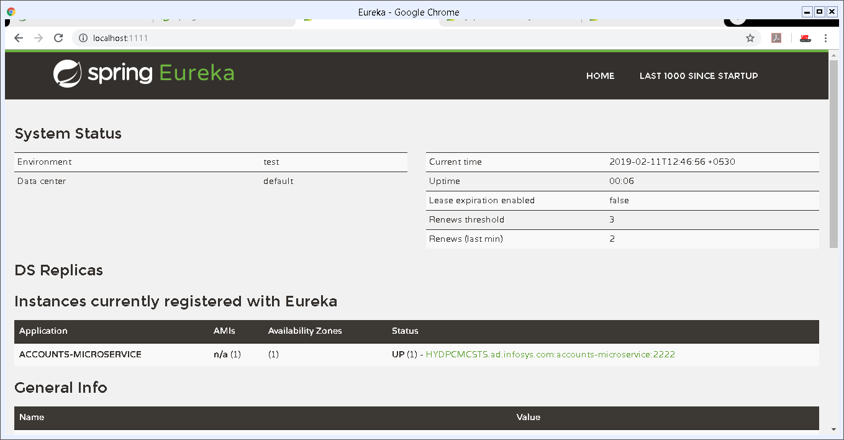
3. Webclient Mroservice server – User will ask for Specific Account details with AccNo
https://github.com/dineshonjava/webclient-microservice-server
Create users to find the Producer Service registered with Discovery Service by adding @EnableDiscoveryClient. This annotation also allows us to query Discovery server to find microservices
@SpringBootApplication
@EnableDiscoveryClient
public class WebclientMicroserviceServerApplication {

public static final String ACCOUNTS_SERVICE_URL = "http://ACCOUNTS-MICROSERVICE";

public static void main(String[] args) {
SpringApplication.run(WebclientMicroserviceServerApplication.class, args);
}

@Bean
@LoadBalanced
public RestTemplate restTemplate() {
return new RestTemplate();
}
@Bean
public AccountRepository accountRepository(){
return new RemoteAccountRepository(ACCOUNTS_SERVICE_URL);
}
}
Now run this consumer service application as Spring Boot application and after few seconds refresh the browser to the home page of Eureka Discovery Server at http://localhost:1111
Now one more Service registered to the Eureka registered instances with Service Name “ACCOUNTS-WEB” as below
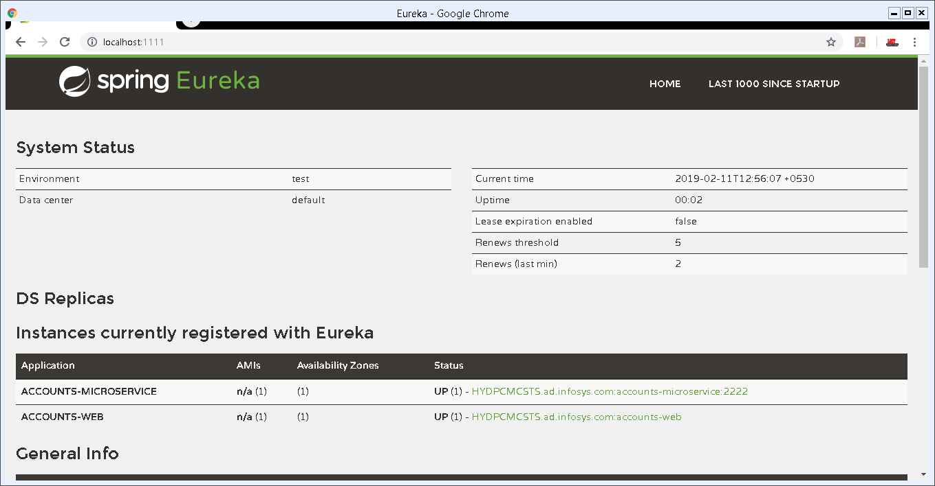
4.Access URL Through Web Application
We already created a Web Application in Webclient Mroservice server to call registred Discovery Server URLs.which is running on
http://localhost:8080/
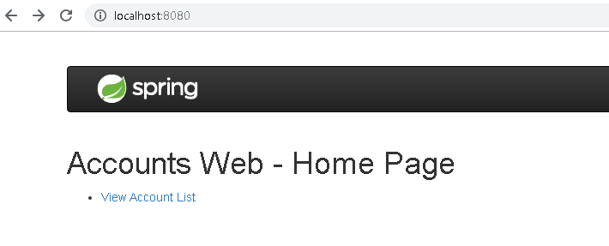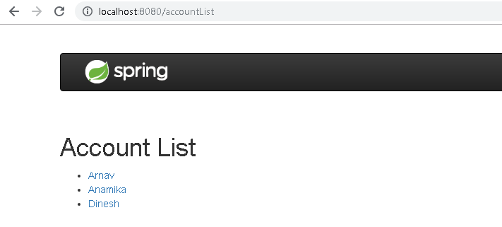

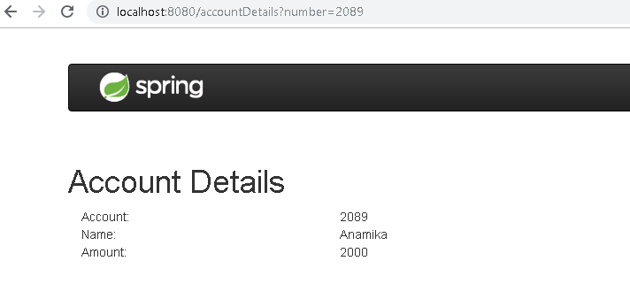

Reactive JavaRx
- Reactive comes from the word react, which means to react to changes in the state instead of actually doing the state change.
- The reactive model listens to changes in the event and runs the relevant code accordingly.
- observer/subscriber attached listening to the stream would receive the data.
The basic building blocks of RxJava are:
- Observables: That emits data streams
- Observers and Subscribers: That consume the data stream. The only difference between an Observer and a Subscriber is that a Subscriber class has the methods to unsubscribe/resubscribe independently without the need of the observerable methods.
- Operators: That transform the data stream
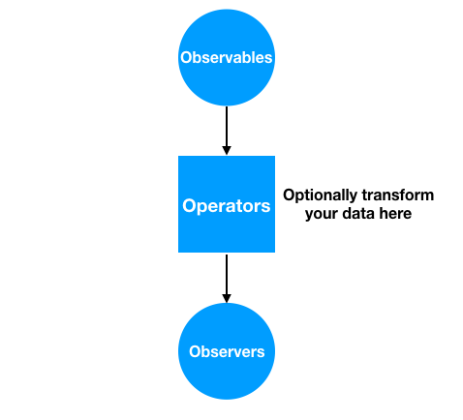

SpringBoot – Reactive Programming
Spring WebFlux framework is part of Spring 5 and provides reactive programming support for web applications
Spring WebFlux internally uses Project Reactor and its publisher implementations – Flux and Mono.
<dependency>
<groupId>org.springframework.boot</groupId>
<artifactId>spring-boot-starter-webflux</artifactId>
<version>2.0.3.RELEASE</version>
</dependency>

We’ll now build a very simple Reactive REST EmployeeManagement application – using Spring WebFlux:
- We’ll use a simple domain model – Employee with an id and a name field
- We’ll build REST APIs for publishing and retrieve Single as well as Collection Employeeresources using RestController and WebClient
- And we will also be creating a secured reactive endpoint using WebFlux and Spring Security
@RestController
@RequestMapping("/employees")
public class EmployeeReactiveController {

private final EmployeeRepository employeeRepository;

@GetMapping("/{id}")
private Mono<Employee> getEmployeeById(@PathVariable String id) {
return employeeRepository.findEmployeeById(id);
}

@GetMapping
private Flux<Employee> getAllEmployees() {
return employeeRepository.findAllEmployees();
}

}

Reactive Web Client
WebClient introduced in Spring 5 is a non-blocking client with support for Reactive Streams.
On the client side, we use WebClient to retrieve data from our endpoints created inEmployeeController.
public class EmployeeWebClient {

WebClient client = WebClient.create("http://localhost:8080");

Mono<Employee> employeeMono = client.get()
.uri("/employees/{id}", "1")
.retrieve()
.bodyToMono(Employee.class);

employeeMono.subscribe(System.out::println);

Flux<Employee> employeeFlux = client.get()
.uri("/employees")
.retrieve()
.bodyToFlux(Employee.class);

employeeFlux.subscribe(System.out::println);

}

AngularJs(Angular 1) vs Angular (Angular 2)
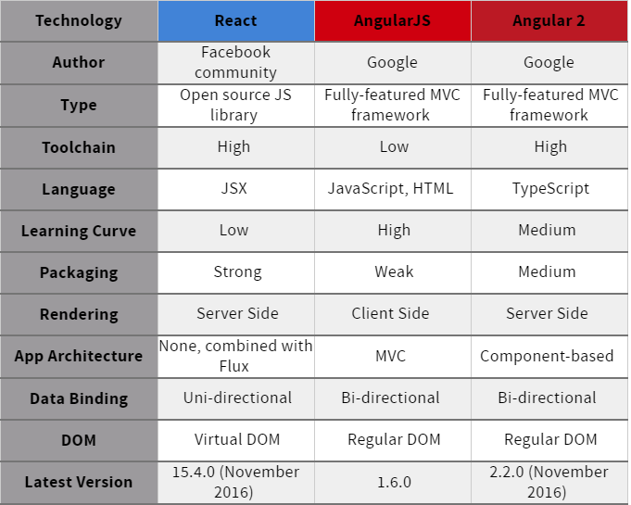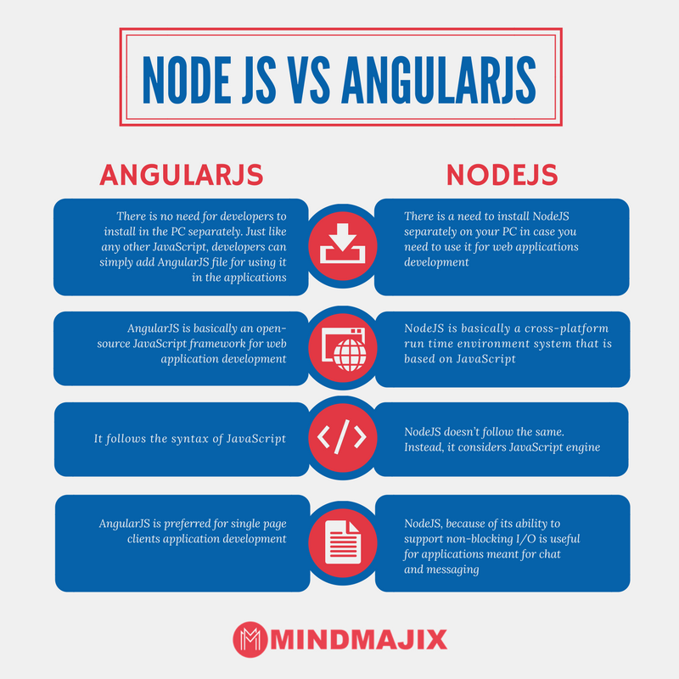

What exactly node.js is?
Is it a web server or a programming language for server-side scripts?
- So here’s how it is, how it’s always been: a browser sends a request to a website. The site’s server receives the request, tracks down the requested file, performs any database queries as needed, and sends a response to the browser. In traditional web servers, such as Apache, each request causes the server to create a new system process to handle that request
- Now think about what that means for a traditional web server like Apache. For each and every user connected to the site, your server has to keep a connection open. Each connection requires a process, and each of those processes will spend most of its time either sitting idle (consuming memory) or waiting on a database query to complete. This means that it’s hard to scale up to high numbers of connections without grinding to a near halt and using up all your resources.

- So what’s the solution? Here’s where some of that jargon from before comes into play: specifically non-blocking and event-driven

- Think of a non-blocking server as a loop: it just keeps going round and round. A request comes in, the loop grabs it, passes it along to some other process (like a database query), sets up a callback, and keeps going round, ready for the next request. It doesn’t just sit there, waiting for the database to come back with the requested info.

- If the database query comes back — fine, we’ll deal with that the same way: throw a response back to the client and keep looping around. There’s theoretically no limit on how many database queries you can be waiting on, or how many clients have open requests, because you’re not spending any time waiting for them. You deal with them all in their own time

- event-driven means: the server only reacts when an event occurs. That could be a request, a file being loaded, or a query being executed — it really doesn’t matter.

How to host node.js applications?
You need to Host AWS or Google Cloud or any other cloud platform because it needs Node.js to be installed.

Npm, bower packges
Let’s understand by Example
I used the complete MEAN stack for this series
MEAN is a set of Open Source components that together, provide an end-to-end framework for building dynamic web applications;
- MongoDB : Document database – used by your back-end application to store its data as JSON (JavaScript Object Notation) documents
- Express (sometimes referred to as Express.js): Back-end web application framework running on top of Node.js
- Angular (formerly Angular.js): Front-end web app framework; runs your JavaScript code in the user’s browser, allowing your application UI to be dynamic
- Node.js : JavaScript runtime environment – lets you implement your application back-end in JavaScript
1.create package.json to install some Node packages.(like maven, here we can see express.js dependency)
//package.json
{
"name": "node-rest-auth",
"main": "server.js",
"dependencies": {
"bcrypt": "^0.8.5",
"body-parser": "~1.9.2",
"express": "~4.9.8",
"jwt-simple": "^0.3.1",
"mongoose": "~4.2.4",
"morgan": "~1.5.0",
"passport": "^0.3.0",
"passport-jwt": "^1.2.1"
}
}

To install pacakges Run
npm install
This will install all our modules to node_modules/.
We can also install one by one without package.json as below, it will get latest version of it
npm install mongojs
npm install express

2.create server.js, here we import all the needed elements and create our server with url localhost:9090
var express = require('express');
var app = express();
var bodyParser = require('body-parser');
var morgan = require('morgan');
var mongoose = require('mongoose');
var passport = require('passport');
var config = require('./config/database'); // get db config file
var User = require('./app/models/user'); // get the mongoose model
var port = process.env.PORT || 9090;
var jwt = require('jwt-simple');

// get our request parameters
app.use(bodyParser.urlencoded({ extended: false }));
app.use(bodyParser.json());

// log to console
app.use(morgan('dev'));

// Use the passport package in our application
app.use(passport.initialize());

// demo Route (GET http://localhost:9090)
app.get('/', function(req, res) {
res.send('Hello! The API is at http://localhost:' + port + '/api');
});

// Start the server
app.listen(port);
console.log('There will be dragons: http://localhost:' + port);

3.config/database.js
module.exports = {
'secret': 'devdacticIsAwesome',
'database': 'mongodb://localhost/node-rest-auth'
};
4. user model for our user authentication
//app/models/user.js
var mongoose = require('mongoose');
var Schema = mongoose.Schema;
var bcrypt = require('bcrypt');

// set up a mongoose model
var UserSchema = new Schema({
name: {
type: String,
unique: true,
required: true
},
password: {
type: String,
required: true
}
});
UserSchema.pre('save', function (next) {
var user = this;
if (this.isModified('password') || this.isNew) {
bcrypt.genSalt(10, function (err, salt) {
if (err) {
return next(err);
}
bcrypt.hash(user.password, salt, function (err, hash) {
if (err) {
return next(err);
}
user.password = hash;
next();
});
});
} else {
return next();
}
});

UserSchema.methods.comparePassword = function (passw, cb) {
bcrypt.compare(passw, this.password, function (err, isMatch) {
if (err) {
return cb(err);
}
cb(null, isMatch);
});
};

module.exports = mongoose.model('User', UserSchema);
Now the basics are set up, and you can start our server from now on just with
node server.js
https://devdactic.com/restful-api-user-authentication-1/

Now NPM vs Bower
Npm and Bower are both dependency management tools. But the main difference between both is
- npm is used for installing Node js modules
- bower is used for managing front end components like html, css, js etc
running bower install will fetch the package and put it in /vendor directory,
running npm install it will fetch it and put it into /node_modules directory.
Grunt is quite different from Npm and Bower. Grunt is a javascript task runner tool. You can do a lot of things using grunt which you had to do manually otherwise
There are grunt plugins for compilation, uglifying your javascript, copy files/folders, minifying javascript etc.

